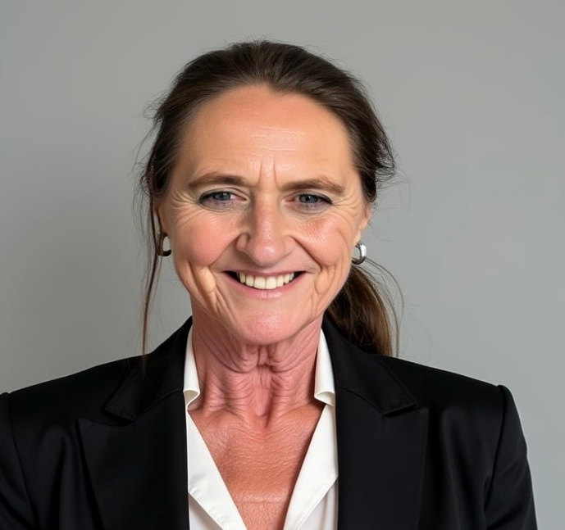

KATHLEEN MILLS BSN RN.
CDONA, FACDONA, CPASRM, QCP, VWCN, and IP.
REGIONAL DIRECTOR OF NURSING
Villa Rica, Ga.
561-262-7609
(Kschuste@Bellsouth.net)

PROFILE

Regional Director of Nursing with extensive experience overseeing multi-facility skilled nursing and sub-acute operations across diverse healthcare markets. Experienced in regulatory compliance, clinical oversight, survey readiness, and operational turnaround, with a strong record of clearing Immediate Jeopardy citations, stabilizing Special Focus facilities, and achieving Five-Star quality outcomes.
Extensive experience conducting nurse consultations and comprehensive reviews of clinical malpractice cases to determine deviations from standards of care. Skilled in analyzing medical records, identifying regulatory deficiencies, evaluating policy adherence, and collaborating with legal counsel to provide recommendations aligned with federal and state healthcare regulations.
Experienced in QAPI implementation, risk management, infection prevention, staff development, and regulatory compliance at both state and federal levels. Adept at mentoring Directors of Nursing, rebuilding clinical infrastructures, and driving measurable improvements in quality metrics, census growth, and financial performance.

SELECTED PROFICIENCIES
• Ethical Compliance and transparency and Regulatory Compliance Management.
• Strong critical thinking and analytic abilities
• Excellent organizational, time management and interpersonal skills with emphasis on
prioritization of duties,
efficiently multi-tasking while providing for exceptional leadership and staff development.
• Root Cause Analysis, Investigation and Data Management including Audits, Tracking and
Trending.

PROFESSIONAL EXPERIENCE

November 2025 to Current Director of Nursing at the William Breman Jewish Home.
Non-for- profit 96 bed skilled nursing home.

August 2022 to Nov 2025 Interim Nurse Consultant.
Director of Nursing Services as well as nurse consultant within various SNF companies, particularly buildings with IJ deficiencies or special focus buildings. Identified issues, established systems while utilizing the Quality Assurance Professional Improvement (QAPI). I develop teams, identify various candidates to mentor into nurse leadership roles withing the skilled nursing facility settings.
The Virginian, Fairfax Va.
Port Square Leesburg Fl. (project management on other identified systems)
Glenview Naples Fl.
Chestnut Ridge Cummings Ga (cleared IJ in abuse, project management in other systems)
Oak Hill, Rhode Island (special focus candidate, cleared 8 IJ, developed a team as well identifying and organizing systems that the current ownership was able to sell facility)
Harbor View, Port Charlotte Fl. (G tag in abuse)
Outcome South. Overseeing five buildings in a change of ownership, total bed capacity 1000.

August 2020 to Sept. 2022 Expert Institute. Nurse Consultant. Reviews clinical malpractice
cases with legal team to determine if any deviations from standards of care were identified. Consulted with legal counsel with recommendations as well as additional deficiencies that may occur based on industry regulatory standards. Remote position.

November 2020 to Feb. 2022 Pyramid Healthcare Management. Chief Nursing Officer.
Clinical oversight of five skilled nursing facilities, (bed capacity
839) to ensure clinical and regulatory compliance. Created
procedures as well as developed plans, goals, and programs to
establish positive outcomes, after change of ownership

August 2019 to Oct. 2020 Signature of Marietta Director of Nursing
Nursing and Rehabilitation Facility
Responsibilities: Director of Nursing as well as overall operations (when Executive Director was on leave) for a 150-bed community.
Established and Supervised the COVID-19 Unit while running the clinical department in both sub-acute and long-term care with minimal loss, while increasing profitability.

December 2017 to Aug. 2019 ANDERSON Mill Health and Rehab Austell Georgia.
Director of Nursing
Responsibilities: Director of Nursing of a 170-bed community
Oversee the clinical department in both sub-acute and long
term. Deficiency free survey.

November 2015 to November 2017 Life Space Communities CCRC. Director of Nursing. Florida
Responsibilities: Director of Nursing/Clinical Director of 100 bed
skilled nursing facility and 14 bed Assisted Living. Provide
clinical direction and assistance with transition from
independent/assisted living to a skilled living environment.
Ensure corporate as well as State Regulation compliance while managing and educating staff. Manage and supervise Risk Management for events and grievances. Assisted with other
Department (Doctors/Hospitals/Bundle Program) as related to census. Five Star

June 2014-November 2015 Darcy Hall Life Care, 240 bed Skilled Nursing Facility.
Responsibilities: Assistant Director of Nursing/Risk Manager overseeing risk management, assuring clinical compliance with state and federal regulations. Number one in region and division for risk management prevention.

May 2005- December 2017 RN Consultant: Palms Edge Assisted Living Facility
RN Consultant Responsible for obtaining Limited Nursing Services License from standard license. Created Policy and Procedures, assisted with re-development of clinical dept. to assure state compliance.

April 2012-Jan.2014 Savannahs Court & Cove Skilled Nursing Facility CCRC. Responsibilities: Clinical Director of Nursing for 30 bed Skilled
Nursing Facility and 114 bed Assisted Living Facility. Scheduling
and management of Licensed Employees. Risk Management,
code compliance and grievance Investigations for all
departments. Admissions, assessments, education of staff,
chart Audits and compliance management.

September 2008- April 2012 Rehabilitation Center of The Palm Beaches. (5 Star)
Responsibilities: Clinical Director of Nursing 100 bed Skilled
Nursing Facility, oversight and management of 111 Employees.
Completion of deficiency free State of Florida survey. Corporate recognition and multiple awards in Clinical Excellence, FIVE STAR CMS STATUS for Palm Beach County.

Initially hired as Risk Manager:
Responsibilities: Accepted Risk Management appointment,
assessed risk vulnerability and liability issues within various
departments. Established cooperation and development
between departments through continuing education.

Certifications/ Education

Bachelor of Science Degree in Nursing, WGU

Associate’s in nursing- Regents College New York

Nominated and accepted as “Fellow in the Academy in the Director of Nursing Administration.”
(FACDONA)

Certified Director of Nursing Association

Certified Risk Manager

Florida Assisted Living Trained

MDS 3.0

QCP

Infection Prevention Certified

Wound Care Certified

Professional References available on request

