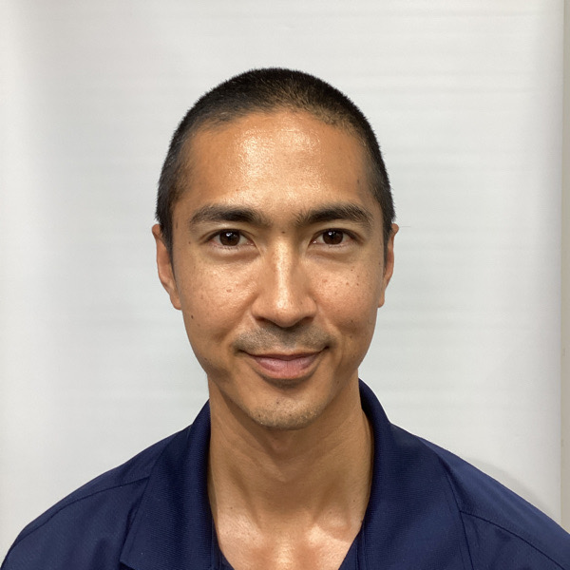 | PATRICK MOON, DPT, OCS  Geriatric Home Health Physical Therapist | Expert Witness  Oakland, CA | (808) 386-4725 | patrickmoonpm@gmail.com | CA License #305283 | ABPTS Board Certified – Orthopaedics

EXPERT WITNESS PROFILE
California-licensed physical therapist specializing exclusively in geriatric home health, with a Doctorate in Physical Therapy from the Army-Baylor University DPT Program and board certification in Orthopedics (OCS) through ABPTS. Has evaluated and treated thousands of geriatric patients in the home setting across more than five years of dedicated home health practice. Conducts 70–80 home visits per week across multiple Medicare-certified home health agencies in the Bay Area — the vast majority of patients are Medicare-age adults presenting with fall history, functional decline, post-surgical recovery, and neurological conditions in the home environment. This high-volume, active clinical practice provides unmatched real-world exposure to home health standard of care, agency protocols, OASIS documentation, homebound status determination, and the practical realities of geriatric PT in the home setting. Prior career as a U.S. Army Physical Therapist (Captain) added clinical depth across outpatient orthopedics, sports medicine, and brigade-level rehabilitation. Available for record review, expert reports, deposition, and trial testimony.

AREAS OF EXPERTISE

• Geriatric physical therapy — home setting  • Falls prevention & fall causation analysis  • Home safety assessment & hazard identification  • Standard of care — home health PT  • Adequacy of PT services & visit frequency | • Homebound status determination  • Medicare home health eligibility & documentation  • OASIS documentation & compliance  • Home health agency protocols & discharge planning  • PT malpractice — home & outpatient settings

PROFESSIONAL EXPERIENCE

Patrick Moon Physical Therapy P.C.  Owner & Physical Therapist — Home Health | Oakland, CA | 2023 – Present
• Solo independent contractor operating across 7–8 Medicare-certified home health agencies in the Bay Area; vast majority of caseload comprises Medicare-age adults
• Conducts 70–80 home visits per week including evaluations, SOCs, recertifications, and skilled PT visits — primary populations include geriatric patients with fall history, functional decline, post-surgical recovery, and neurological conditions
• Deep expertise in geriatric assessment in the home environment: fall risk, balance, gait, functional mobility, home hazard identification, and caregiver training
• Expert in OASIS documentation, homebound status determination, and Medicare home health compliance across multiple EMR platforms (Axxess, Kinnser/WellSky, Devero/Netsmart, HHMD)
• Extensive exposure to varied home health agency protocols, care coordination standards, and discharge planning practices across the Bay Area market

U.S. Army Medical Department — Physical Therapist  Captain, U.S. Army | Multiple Installations | 2018 – 2023
• Served as Brigade Physical Therapist responsible for musculoskeletal health, injury prevention, and rehabilitation of active duty soldiers
• Operated outpatient orthopaedic and sports medicine clinic; managed satellite clinic operations
• Treated high-volume, high-acuity patient population including complex orthopedic, sports, and performance-related injuries
• Completed concurrent DPT training at Army-Baylor University while on active duty (2015–2018)

EDUCATION

Doctor of Physical Therapy (DPT)  Army-Baylor University DPT Program | Fort Sam Houston, TX | 2018

Bachelor of Arts — Psychology  University of Hawaiʻi at Mānoa | Honolulu, HI | 2013

LICENSURE & CERTIFICATION

California Physical Therapist License  #305283 — Active | 2023 – Present

Hawaii Physical Therapist License  Active | 2018 – 2023

Board Certified Orthopedic Clinical Specialist (OCS)  American Board of Physical Therapy Specialties (ABPTS) | Active

Dry Needling Certified | Active

Osteopathic Manipulation Techniques | Active

PROFESSIONAL MEMBERSHIPS

• American Physical Therapy Association (APTA)

EXPERT WITNESS AVAILABILITY

Available for record review, written expert reports, deposition testimony, and trial testimony. Cases accepted on both plaintiff and defense sides. Retainer required prior to record review. Please contact directly to discuss case details and availability.

