ALBERT W. CHO, M.D.

9200 Las Manaitas Ave Unit 402
Las Vegas, NV 89144 (574) 850-4063 albert.cho@stanfordalumni.org
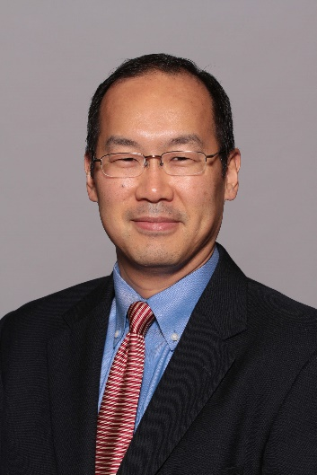

____________________________________________________________________________

PROFESSIONAL EXPERIENCE
SimonMed Imaging, Scottsdale, Arizona
October 2022 to present

Radiology, Inc., South Bend, Indiana
August 2007 to August 2022

The Permanente Medical Group, San Francisco, California
July 2003 to July 2007

POST GRADUATE TRAINING
Northwestern Memorial Hospital, Chicago, Illinois
Body Imaging (MRI) Fellowship
July 2002 to June 2003

Loyola University Medical Center, Maywood, Illinois
Chief Resident
Diagnostic Radiology Residency
July 1998 to June 2002

West Suburban Hospital Medical Center, Oak Park, Illinois
Transitional Year Residency
July 1997 to June 1998

EDUCATION
University of Illinois at Chicago College of Medicine, Chicago, Illinois
Doctor of Medicine, May 1997

Stanford University, Stanford, California
Bachelor of Science in Biological Sciences, June 1993
PROFESSIONAL ACTIVITIES
Elkhart General Hospital Department of Radiology Chairman, 2020-2021 (2-year term)
- Member of the Elkhart General Hospital (EGH) Medical Executive Committee
- Interfacing with the EGH executive staff in assistance of running EGH, with particular focus on the Radiology Department, including equipment purchase recommendations, department budget development, and development of department policies/procedures.
- Member of the Radiology Inc Executive Board
Elkhart General Hospital Department of Radiology Vice Chairman, 2012, 2014-2019
- Management of the Radiologist staff at EGH
- Alternate representative (to the Chairman) to the EGH Medical Executive Committee and Radiology Inc Executive Board
- Radiology technologist education at modality meetings
Elkhart General Hospital IRB Member, 2014-2022
- Physician member of the IRB, helping to provide the non-medical Board members the explanation of the background medical information necessary for analysis of medical research studies discussed
Volunteer Clinical Assistant Professor of Radiology and Imaging Sciences, Indiana University School of Medicine-South Bend, 2014-2022
- Proctoring of medical students in their clinical Radiology rotations
Radiology Inc. Operations Committee Chairman, 2013-2016, 2019
- Lead in developing and standardizing imaging protocols across all practice hospital and outpatient imaging sites
Elkhart General Hospital Radiology Quality Assurance Committee Chairman, 2012-2019
- Administration of the Radiologist peer review process, including review of and education regarding missed cases with interpreting Radiologists
- Transition from Peer Review to Peer Learning for Radiologist professional improvement process
Radiology Inc. Executive Board Member at Large, 2012-2016, 2018
- Member of 11-person Board which managed the Radiology private practice group, which included making financial, staffing, and practice growth decisions
Imaging Utilization Chief for the SF site to the Kaiser Regional Imaging Utilization Committee, 2005-2007
- Implementation of standardized imaging protocols in the Radiology department through technologist education
- Point person at the San Francisco practice site to ordering providers for education of best imaging practices
Kaiser Regional CT/MRI Protocol Committee, 2004
- Member of regional committee which developed and standardized imaging protocols to be used at all Northern California practice sites

SOCIETY MEMBERSHIPS
Radiological Society of North America
American Roentgen Ray Society
Society for Advanced Body Imaging

PUBLICATION
S. Patel, A. Cho, A. Lamont, T. Klatt-Ellis. Implementing a Community Hospital Lung Cancer Screening Program: A Multidisciplinary Program and a Standardized Reporting System. Journal of the American College of Radiology 11(5): 527-530, 13 February 2014.

LICENSURE AND CERTIFICATION
American Board of Radiology, Board Certified
Active Medical Licensure: Nevada, Arizona, Florida.

