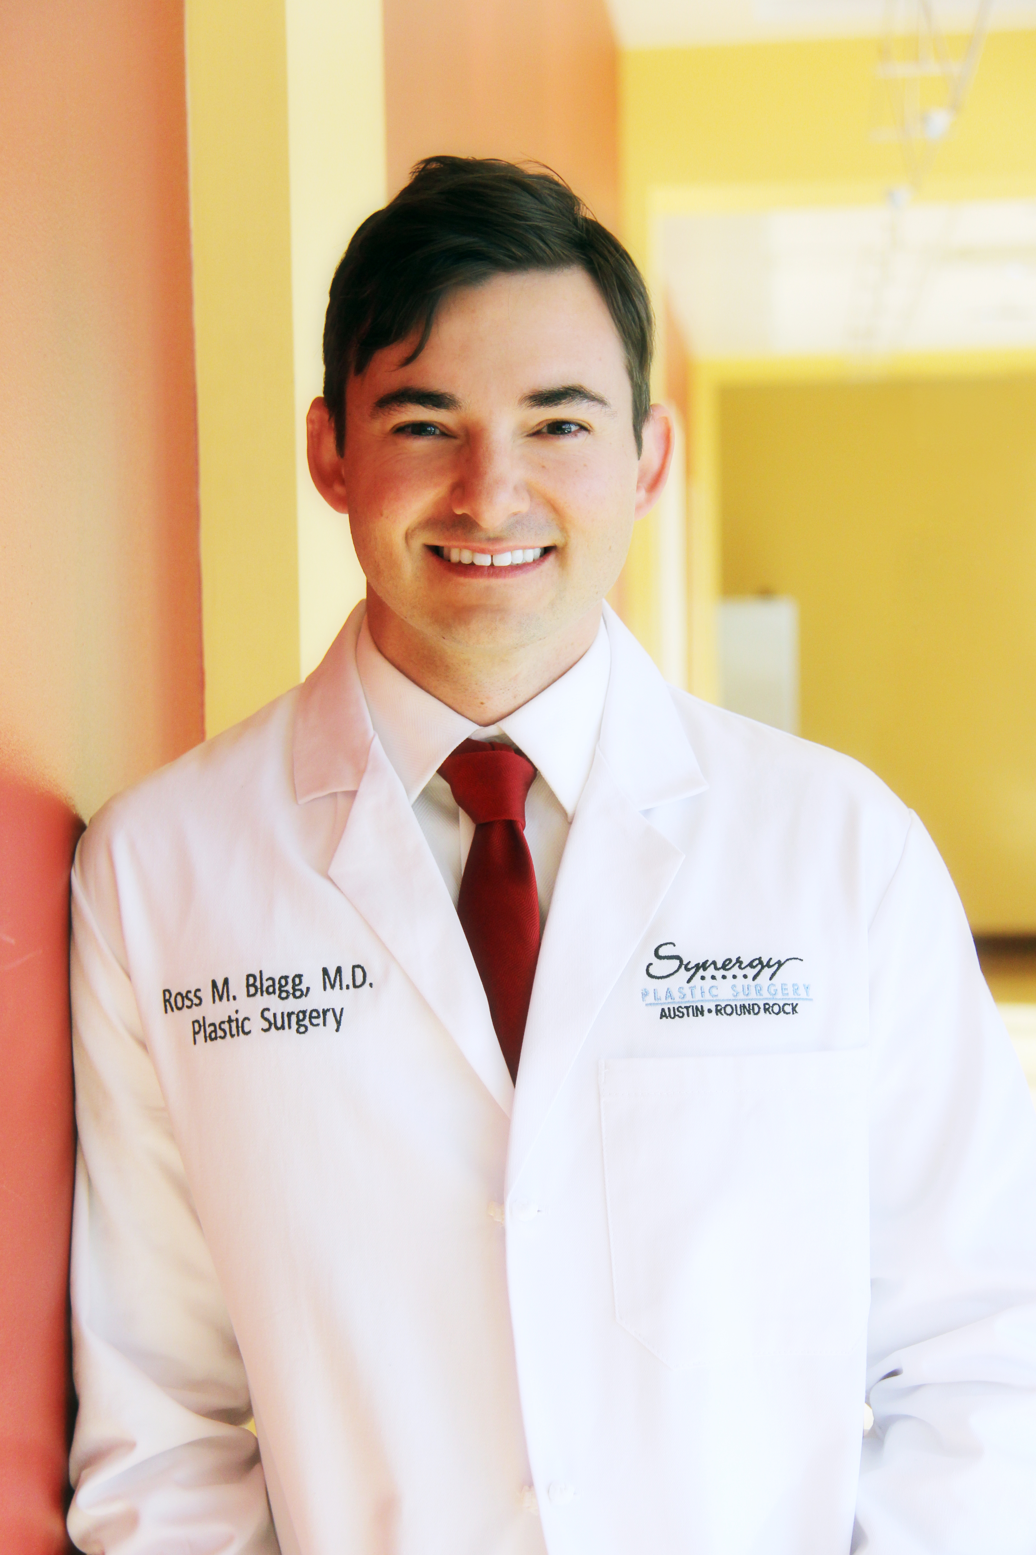
Curriculum Vitae
Ross M. Blagg, M.D.
Board Certified by The American Board of Plastic Surgery
Plastic, Cosmetic & Reconstructive Surgery

Synergy Plastic Surgery - Austin
11200 Manchaca Road, Suite 201, Building 2
Austin, TX 78748

Synergy Plastic Surgery - Round Rock
7700 Cat Hollow Drive, Suite 103
Round Rock, Texas 78681

Synergy Plastic Surgery – Westlake
3355 Bee Caves Road, Bldg 4, Suite 401
Austin, TX 78746

Phone (512) 244-1444
Fax (512) 244-1445
Web: www.synergyplasticsurgery.com

Professional Societies:
American Society of Plastic Surgeons
American Society for Aesthetic Plastic Surgeons
American Society of Craniofacial Surgery (ASCFS)
American Cleft Palate-Craniofacial Association (ACPA)
Travis County Medical Society
Texas Medical Association

Academic Appointments:
Clinical Assistant Professor of Surgery, Texas A&M Health Sciences Center College of Medicine

Professional Education:

Fellowship:
Craniofacial/Pediatric Plastic Surgery Fellowship: University of Utah Division of Plastic Surgery. Salt Lake City, Utah.

Residency:
Combined Plastic and Reconstructive Surgery Residency: University of Utah Division of Plastic Surgery. Salt Lake City, Utah.

Medical School:
University of Arkansas for Medical Sciences: Little Rock, Arkansas. Doctor of Medicine.

Undergraduate:
University of Arkansas: Fayetteville, Arkansas. Degree: Bachelor of Science in Biology.
James Cook University: Cairns, Queensland, Australia. Focus: Marine Biology.
La Academia Latinoamericana de Espanol: Quito, Ecuador. Focus: Spanish.
Sea-mester-Florida Keys Community College: Caribbean Ocean. Focus: Oceanography & Seamanship.

Professional Honors & Awards:
- Dr. George S. Wise Memorial Scholarship for Humanism in Medicine
- Barton Foundation Medical School Scholarship
- University of Louiseville College of Medicine Plastic Surgery Research Fellowship
- RealSelf Top Doctor
- Synthes Resident Educational Grant
- Winner of American College of Surgeons, Resident Association Section Essay Competition
- Alpha Omega Alpha National Honors Society
- General Surgery Department Edward Forrest Ellis Award for senior medical student showing the most promise in the field of surgery
- Butler University Study Abroad Scholarship
- Sigma Phi Epsilon Balanced Man Scholarship
- University of Arkansas Chancellor’s Scholarship
- Arkansas Distinguished Governor’s Scholarship

Professional Organizations, Memberships, and Privileges:
- Member, American Board of Plastic Surgery
- Surgeon, Plastic & Reconstructive Surgery: St. David’s Round Rock Medical Center. Round Rock, Texas.
- Surgeon, Plastic & Reconstructive Surgery: St. David’s North Austin Medical Center. Austin, Texas.
- Member, Texas Medical Association
- State Delegate, American Medical Association
- Innovations in Undergraduate Medical Education Advisory Committee, University of Utah College of Medicine
- Student Housestaff Advisory Committee for Retention, University of Utah Hospitals
- LEAN Project Advisory Committee, University of Utah Hospitals
- Humanitarian Plastic Surgery, Founder
- Attending Surgeon (past), Plastic & Reconstructive Surgery: University of Utah Hospital/Veteran’s Administration hospital/Primary Children’s Hospital. Salt Lake City, Utah.

Peer-Reviewed Research Publications:
Vasilic D, Barker JH, Blagg R, Whitaker I, Kon M, Gossman MD. (2010) Facial Transplantation: An Anatomic and Surgical Analysis of the Periorbital Functional Unit. Plast Reconstr Surg 125:1, 125-134
Emre V, Berbee M, Acott A, Blagg R, Fan CY, Hauer-Jensen M. (2010) Skin graft take rates, granulation, and epithelialization: dependence on myeloid cell hypoxia-inducible factor 1 alpha. Arch Otolaryngol Head Neck Surg 136:7, 720-723.
Blagg R. (2012) Reining in the scalpel. B Am Coll Surg 97:11, 22-23.
Gociman B, Agko M, Blagg R, Garlick J, Kestle JR, Siddiqi F. (2013) Endoscopic-assisted correction of metopic synostosis. J Craniofac Surg 24:3, 763-768.
Blagg R. (2013) Legislated Mints on the Pillow. B Am Coll Surg 98:11, 27-29.
Blagg R, Rockwell WB. (2014) Symptomatic elbow ganglion causing pronator syndrome. Plast Reconstr Surg Glob Open 2:e, 109.
Gociman B, Blagg R, Agko M, Goodwin I, Kestle JR, Siddiqi F. (2014) The metopic angle: a novel assessment tool of the trigonocephalic frontal deformity and its correction. J Craniofac Surg 25:6, 2101-2104.
Sivakumar W, Goodwin I, Blagg R, Johns D, Riva-Cambrin J, Siddiqi F, Gociman B. (2015) Pancraniosynostosis following endoscopic-assisted strip craniectomy for sagittal suture craniosynostosis in the setting of poor compliance with follow-up: a case report. J Med Case Rep 9:64.
Johns D, Blagg R, Kestle JR, Riva-Cambrin JK, Siddiqi F, Gociman B. (2015) Distraction osteogenesis technique for the treatment of nonsyndromic sagittal synostosis. Plast Reconstr Surg Glob Open. 10:3(7).
Book Publications and Chapter Publications:
Blagg R. Life After Massive Weight Loss: Skin Removal Surgeries. Publisher: Smashwords. 2016. https://www.smashwords.com/books/view/631340
Blagg R. Crombie C. Skin Closure After Resection of Skin Malignancies. (Accepted: In: Textbook of Complex General Surgical Oncology) Publisher: McGraw-Hill.
International & National Research Presentations:
12th International Congress on Cleft Lip/Palate and Related Craniofacial Anomalies. Presented May 7, 2013. Authors: Blagg R, Siddiqi F, Gociman B. The Metopic Angle: A novel assessment tool of the trigonocephalic frontal deformity secondary to metopic synostosis. Abstract presented by: Dr. Ross Blagg.

International & National Research Presentations:
American College of Surgeons, Annual Meeting. Presented September 13, 2013. A Model For University Based International Plastic Surgery Collaboration Builds Local Sustainability. Authors: Blagg R, Rockwell WB. Abstract presented by: Dr. Ross Blagg.
Mountain West Society of Plastic Surgery, Annual Meeting. Presented March 5, 2016. Distraction Osteogenesis Technique for the Treatment of Nonsyndromic Sagittal Synostosis. Authors: Blagg R, Kestle J, Siddiqi F, Johns D, Gociman B. Abstract presented by: Dr. Ross Blagg.

International Plastic Surgery Missions:
Austin Smiles Foundation Surgery Mission: San Salvador, El Salvador. 2022, 2023
Northwest Haiti Christian Administration Surgery Mission: Saint-Louis-du-Nord, Haiti. 2017
Northwest Haiti Christian Administration Surgery Mission: Saint-Louis-du-Nord, Haiti. 2012
Hirsche Smiles Foundation Surgery Mission: Guatemala City, Guatemala. 2014.
Hirsche Smiles Foundation Surgery Mission: Guatemala City, Guatemala. 2016.
Academic Research Experience:
Research Fellow: University of Louisville School of Medicine.
Plastic Surgery Research Fellowship received for participation in research leading to the first facial transplant in the United States. Project involved anatomical dissections of the peri-orbital regions of the face for consideration of nerve regeneration and return of peri-orbital function following full facial transplantation.

Licenses:
- Physician and Surgeon, State of Texas.
- Federal DEA License Current.

