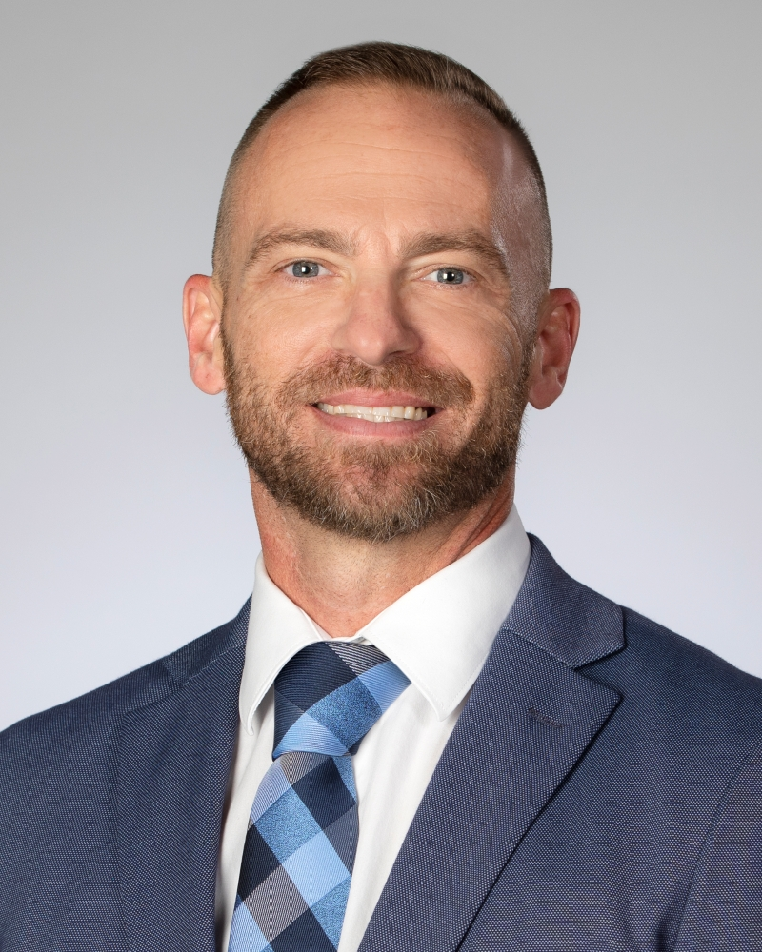
Service Offerings Available

- Litigation Support
- Deposition and Trial Support
- Accident Reconstruction
- Courtroom Presentations
- Technical Evidence Review
- Forensic Engineering

- Air Quality Engineering
- Safety Engineering
- Environmental Engineering
- Production Engineering
- Regulatory Compliance Evaluations

- EHS Due Diligence
- EHS Auditing
- Risk Management
- Occupational Health Management

Employment

Inertia Consulting (Edmond, OK) – Owner/Managing Partner 07/2020 – Present
(Privately owned consulting firm specializing in HSE service provision primarily in the oil and gas industry)
HSE Engineer/Managing Partner/Owner
Company owner responsible for delivering fit-for-purpose/economic solutions to complex problems.
- Litigation support – consulting on injury related and risk related cases
  - Expert testimony, courtroom presentations, evidence review and analysis, case review
  - Regulatory analysis and applicability determinations
  - Incident investigations and root cause analysis
  - OSHA investigation management
- Accident/incident investigations, root cause analysis, contributing factors analysis
- Incident management, direct investigations, coordinate corrective actions, report serious incidents to regulatory authorities, manage investigations and legal interactions
- Deep-dive auditing of compliance programs/outcomes/challenges
- Professional speaker – public speaker and writer on HSE and risk related topics

Blackbeard Holdings (Tulsa, OK) 10/2019 – 10/2022
(Private upstream O&G with $1.9 billion in assets and <300 employees, service and midstream companies under management)
HSE Engineer/Manager
Top HSE position responsible for planning, implementing, and directing strategies and programs to ensure compliance with all applicable safety, health and environmental regulations and requirements. Role focuses on establishing a corporate strategy to reduce overall workplace accidents and incidents.
- Responsible for developing and implementing a global HSE management system designed for sustainable and effective compliance
- Incident management, direct investigations, coordinate corrective actions, report serious incidents to regulatory authorities, manage investigations and legal interactions
- Ensure integration and communication across all company disciplines
- Design processes for related HSE functions to ensure reliable execution, consistent quality and reduce risk
- Report to and support COO in all aspects of operational excellence
- Develop companywide training program designed for engagement, retention, and education

Tecolote Energy LLC (Tulsa, OK) 11/2016 – 10/2019
(Private equity backed, upstream O&G company with $630 million in assets and <100 employees)
EHS & Regulatory Engineer/Manager (11/2016 – 10/2019)
Top EHS position responsible for planning, implementing, and directing strategies and programs to ensure compliance with all applicable safety, health and environmental regulations and requirements. Role focuses on establishing a corporate strategy to reduce overall workplace accidents and incidents.
- Responsible for developing and implementing a global EHS and Regulatory management system designed for sustainable and effective compliance
- Incident management, direct investigations, coordinate corrective actions, report serious incidents to regulatory authorities, manage investigations and legal interactions
- Design process maps for all related functionalities to ensure reliable execution
- Manage all field level EHS employees to maximize their value to the organization
- Develop companywide training program designed for engagement, retention, and education
- Drove TRIR to zero within 1 year, MVA rate = 0 for 2 years
Production Engineer (11/2017 – 10/2019)
Oversee daily operation of well group, including well performance, planning, and supervising workover operations, and maximizing recovery utilizing a variety of artificial lift technologies. Responsible for design and implementation of subsurface equipment and surface facilities.
- Analyze, interpret, and optimize the performance of individual wells
- Identify wells for production enhancements, created over $ 5.1 MM in uplift revenue in 2 years
- Maximize daily production and ultimate recovery from producing wells
- Development of surface production systems
- Determine most cost-effective artificial lift mechanisms for depleted wells, managed >100 successful workover projects
- Responsible for all plugging and abandonment projects, plugged >80 wells

Midstates Petroleum Company (Tulsa, OK) 1/2015 – 11/2016
(Publicly traded upstream O&G company with $600 million in assets and 125 employees)
Environmental & Air Program Manager
Plans, manages, and directs company efforts relative to environmental compliance, air permitting, control strategies, and remedial obligations. Requires individuals with thorough knowledge of environmental regulations and the ability to communicate with and influence representatives from state, federal and local governments.
- Air Program Manager – developed and implemented air program from ground up covering all of Midstates’ operations. Internalized all air permitting for cost saving of $ 1.3 MM annually. Developed permitting and control strategies saving $ 4.5 MM overall.
- Remediation Project Manager – Achieved company savings of $ 7.0 MM within 18 months, closing over 30 open projects, and another 110 that arose during my tenure
- Environmental Team Manager – Designed and deployed compliance programs covering air, land, water, waste; built process to gauge overall program performance
- Incident management, direct investigations, coordinate corrective actions, report serious incidents to regulatory authorities, manage investigations and legal interactions

Samson Resources (Tulsa, OK) 10/2012 – 1/2015
(Privately owned upstream O&G company with $1.3 billion in assets and 1,000 employees)
Corporate HSE Speciliast/Air Quality Program Manager
Plans, manages, and directs company efforts relative to air permitting, control strategies, and reporting obligations. Develop comprehensive company-wide program to achieve reliable and sustainable compliance.
- Air Quality, Permitting, and Process Simulation Expert – VMGSim (v7) software utilized for facilities and district engineering support, assisting in flash emission evaluations and vapor characterization for proper control equipment selection; deployed control strategy saving company $ 2.5 MM over 2 years
- Tank Vapor Specialist – designed and implemented strategies to predict tank vapor mass flows and needed control solutions by basin/state and developed basin-specific flash curves for operational parameters
Project Manager – particularly Quad Z/J/I and Quad O initiatives, including GHG, control tech runtime tracking and data capture, and emissions estimation techniques for actual emissions calculation
- Engine Specialist – on engine compliance and emissions, stack test bid proposal development, stack test methods, and participate in assisting emissions challenges in field
- Regulatory and Compliance Process Design/Implementation Specialist – on permitting and compliance initiatives, strategy development, compliance metrics

Chesapeake Operating, Inc. (Shreveport, LA) 04/2009 – 09/2012
(Publicly traded upstream O&G company with $4 billion in assets and over 3000 employees)
EHS Field Specialist
Assist in the implementation of EHS programs for operations in designated regions. Continuously work with operations team to ensure long-term, sustainable programmatic implementation.
- Air Permitting and Compliance Specialist – provided support to operational endeavors to ensure compliance with state and federal regulations, ensuring field compliance requirements and strategies were effective
- Remediation Project Manager – closed over 100 remediation projects with company
- Regulatory Liaison – coordinated meetings with regulatory officials, developed improved communications policies with agency management
- Participate in legal support, depositions, and insurer interactions
- EHS Contractor Manager – managed a team of contractors dedicated to helping Chesapeake comply with federal/state regulations
- Incident management, lead field investigations, develop corrective actions, report serious incidents to regulatory authorities, manage investigations and legal interactions

C-K Associates (Shreveport, LA) 11/2005 - 04/2009
(Private company with $100 million in assets and 150 employees)
Contract HSE Field Specialist
- Contract environmental and safety specialist focusing on air permitting, emissions calculations, compliance strategy development and execution, RMP development, and incident investigations
- Respond to incidents that occurred in my district, assist corporate HSE with accident investigations
- Assist in implementation of corporate led programs
- Incident management, lead field investigations, develop corrective actions, report serious incidents to regulatory authorities, manage investigations and legal interactions

Texas A&M University 05/2003 – 11/2005
- Graduate Researcher and laboratory professor

University of Texas, Tyler, TX - Undergraduate Researcher 09/1998 – 05/2003
- Undergraduate researcher and teacher

Education
Iowa State – Master’s Degree – Mechanical Engineering (focused on thermo and fluid dynamics) – 3.9 GPA
University of Texas at Tyler - B.S. (Biology, minor in Chemistry) - 3.4 GPA
Whitehouse HS – National Merit Scholar, Who’s Who Listed, Full Academic Scholarship Winner to University of Texas at Tyler

Associations
- National Association of Forensic Engineers, National Association of Professional Engineers, American Gas Association, Texas Gas Association, Society of Petroleum Engineers, American Society of Safety Professionals

Governmental Agency Experience
- OSHA, EPA, ODEQ, TCEQ, LDEQ, WDEQ, NDDH, RRC, OCC

