Joshua M. Verson, MD, FACEP
Emergency Medicine
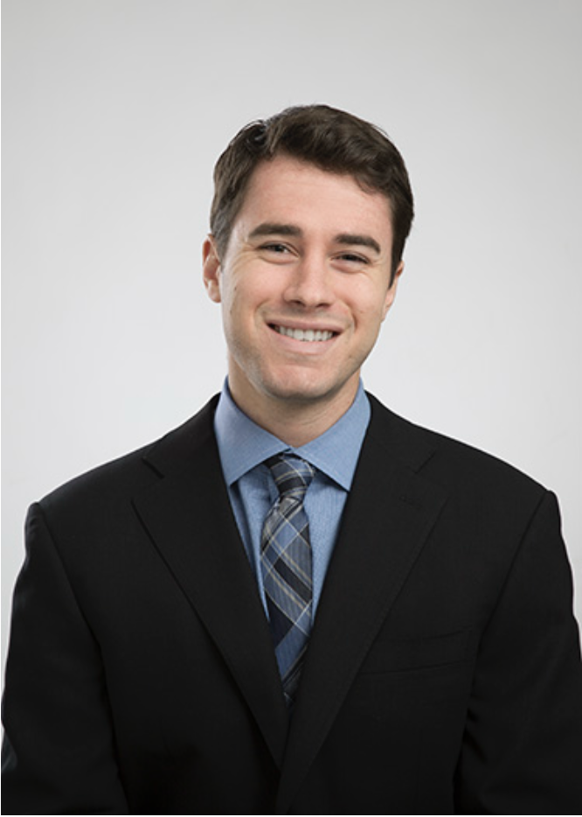
Phoenix, AZ
joshverson1@gmail.com
Cell: 847-767-0052
www.linkedin.com/in/josh-verson-796905121/

Board-Certified Emergency Medicine Physician in active clinical practice. Experience as an EM clinician in diverse practice settings including Level 1 and 2 Trauma Centers, Community Hospitals, Micro-hospitals, Free-Standing Emergency Rooms, and Indian Health Service facilities. Creighton University School of Medicine Faculty.

PROFESSIONAL EXPERIENCE

Chandler Regional Medical Center - Trauma Level 1,
Mercy Gilbert Hospital,
East Valley Emergency Medicine Residency,
Creighton University School of Medicine, Chandler, Arizona 2021 – Present
Emergency Department Physician, Clinical Faculty – Emergency Medicine
Serves as an attending emergency medicine physician and assistant professor, supervising residents and medical students in a high acuity, Level I Trauma Center and Comprehensive Stroke Center with more than 70,000 ED visits annually. The sister hospital, Mercy Gilbert is a community hospital with a new on-site Pediatric Emergency Department in collaboration with Phoenix Children’s, providing safe, efficient, and evidence-based emergency care to the local community.

Northwest Medical Center - Trauma Level IV, Tucson, Arizona 2021 - Present
Emergency Department Physician, Senior Attending
High-volume Level IV trauma community hospital providing full-spectrum emergency care to adult and pediatric patients in a busy regional referral center.

East Valley ER and Hospital/Phoenix ER, Gilbert, Arizona 2022 - Present
Emergency Department Physician, Senior Attending
Physician-led emergency rooms and micro-hospitals with limited inpatient beds, providing comprehensive emergency and short-stay care to the community with a focus on efficiency, safety, and personalized patient experience.

Hu Hu Kam Memorial Hospital, Sacaton, Arizona 2024 - Present
Innova Emergency Medical Associates, P.C.
Emergency Department Physician, Senior Attending
Provides comprehensive emergency medical care at a federally operated Indian Health Service hospital serving the Tohono O’odham Nation, managing a full spectrum of acute presentations in a resource-limited, rural setting.

Phoenix Indian Medical Center, Phoenix, Arizona 2024 - Present
Prairie Band LLC
Emergency Department Physician, Senior Attending
Urban Indian hospital serving the Native American community, delivering full-spectrum emergency care in a high-acuity setting with an emphasis on culturally competent practice and multidisciplinary collaboration.

TEC Health- The Emergency Center, Phoenix, Arizona 2025 - Present
Emergency Department Physician, Senior Attending
Serves as an emergency physician in a values-driven, community-based system which includes 13 free-standing emergency rooms and two multi-specialty receiving acute care hospitals dedicated to delivering compassionate, patient-centered care. We provide high-quality, individualized treatment in a supportive environment that redefines the traditional emergency medicine model.

SteerBridge-Strategies, online/remote 2025 - Present
Medical Disability Examiner
Conduct thorough medical record reviews and complete VA Disability Benefits Questionnaires using the ACE methodology to support accurate, evidence-based compensation determinations for Veterans. Ensure compliance with VA standards while delivering precise, high-quality evaluations that advance mission efficiency and care for those who served.

National Geographic/Lindblad Expeditions, varies 2025 - Present
Shipboard Physician
Provide emergency and primary medical care for guests and crew aboard expedition vessels in remote environments, ensuring health and safety during voyages to challenging global destinations.

BOARD CERTIFICATION & LICENSURE

American Board of Emergency Medicine Certification 2022 - Present
Arizona Medical License (#60996) 2018 - Present
Advanced Cardiac Life Support 2018 - Present
Basic Life Support 2018 - Present
Advanced Pediatric Life Support 2018 - Present
Advanced Trauma Life Support 2018 - Present

EDUCATION

University of Arizona College of Medicine, Tucson, Arizona 2018-2021
Residency, Emergency Medicine

Rush Medical College, Chicago, Illinois 2014-2018
Doctor of Medicine

University of Michigan, College of Literature Science and Arts, Ann Arbor, Michigan 2010-2014
Bachelor of Science in Neuroscience

PRESENTATIONS & LECTURES

East Valley Emergency Medicine Residency Program, Chandler, Arizona
Residency Lectures:
- Intern Finances 101 July 2024

University of Arizona, Department of Emergency Medicine, Tucson, Arizona
Residency and Medical Student Lectures:
- Continuous Process Improvement: Carbon Monoxide & Cyanide Poisoning July 2020
- Approach to Pediatric C-spine Injury in the ED June 2020
- Lumbar Punctures June 2020
- Abnormal Uterine Bleeding & Preeclampsia/Eclampsia May 2020
- Approach to Pediatric Head Trauma in the ED May 2020
- Focus Assessment with Sonography in Trauma January 2020
- Pediatric Abdominal Pain September 2019
- Ultrasound Guided Nerve Blocks December 2019
- Continuous Process Improvement: Proper Neonatal Resuscitation in the ED November 2019
- Distal Forearm Fractures and Methods for Sedation September 2019
- Pediatric Seizures September 2019

GRANTS

University of Michigan Center for Global Health, Ann Arbor, MI March 2012

Primary Author
- $19,620.00 grant awarded for the development of Disaster Acute Rehabilitation Team (DART) Training Program for the International Society for Physical and Rehabilitation Medicine, University of Michigan Center for Global Health

COMMITTEES

University of Arizona, Tucson, AZ 2018-2021
Selected Interviewer, Emergency Medicine Residency
Interview and Recruitment of UA Emergency Medicine Applicants

Rush Medical College Ambassador Program, Chicago, IL 2015-2018
Medical Student Applicant Interviewer
Provide advice about interviewing, medical school academics, and community service opportunities to prospective Rush Medical College applicants while leading campus tours

Rush Medical College Emergency Medicine, Chicago, IL 2016-2018
Interest Group Leader

MEMBERSHIPS

Member, Emergency Medicine Residency Association 2018-Present
Fellow, American College of Emergency Physicians 2018-Present

JOURNAL PUBLICATIONS

- Verson J, Dyga N, Agbayani N, Serafin F, Hondros. Design and Evaluation of a Medical Student Disaster Response Team: The Medical Student HazMat Team. Medical Teacher. 2017 July.

- Verson J, Egusquiza A, Nguyen D. A Diagnosis More Than Skin Deep: A Case of Late-Stage Pulmonary Langerhans’ Cell Histiocytosis. Case Reports in Internal Medicine. 2017 January; 4(1):68-71

- Verson J, Haig A, Sandella D, Yamakawa K. Patient Perception of Pain vs. Observed Pain Behavior During a Standardized Electrodiagnostic Test. Journal of Muscle and Nerve. 2015 February; 51 (2):185-91

ORAL PRESENTATIONS

University of Michigan, Department of Physical Medicine & Rehabilitation, Beijing, China June 2013
Invited Speaker at the International Society of Physical and Rehabilitation Medicine Conference (ISPRM)
Supervisor: Andrew Haig, MD
- Data collection from the post-disaster nations of western China, Chile and Taiwan
- Developed a curriculum for the Disaster Acute Rehabilitation Team at the ISPRM conference in Beijing, China 2013
- Demonstrated how an advanced and collaborative training program can be implemented to teach rehabilitation physicians strategies to best provide care following a natural disaster

ABSTRACT PRESENTATIONS

- Verson J, Dyga N, Serafin F, Hondros L. Rush’s Medical Student HazMat Team. University of Miami Miller School of Medicine: Department of Community Service (DOCS) Community Health Leadership Conference. Miami, Florida. March 2017.

- Verson J, Egusquiza A, Nguyen D. A Diagnosis More Than Skin Deep: A Case of Late-Stage Pulmonary Langerhans’ Cell Histiocytosis. 34th Annual Rush University Forum for Research and Clinical Investigation. Chicago, Illinois. March 2017.

- Verson J , Kent P. Severe Radiation Recall in Tissue & Lung After High Dose Stereotactic Radiosurgery in a Child. American Society of Pediatric Hematology & Oncology. San Diego, California. April 2015.

- Verson J, Kent P. Fatal Tumor Lysis Syndrome triggered by Laparoscopic Biopsy in Burkitt’s Lymphoma. American Society of Pediatric Hematology & Oncology. San Diego, California. April 2015.

- Verson J, Haig A, Wen H, Johnson L, Chen Y-C, Li J. Building the ISPRM Disaster
Acute Rehabilitation Team Program (DART). International Society for Physical and
Rehabilitation Medicine (ISPRM). Beijing, China. June 2013.

- Verson J, Haig A, Sandella D, Yamakawa K, London Z. Patient perception of pain versus observed pain behavior during a standardized electrodiagnostic test. International Society for Physical and Rehabilitation Medicine (ISPRM). Beijing, China. June 2013.

RESEARCH EXPERIENCE

University of Arizona, Department of Emergency Medicine, Tucson, AZ 2018-2021
Co-Investigator- The Effects of Pre-Hospital Characteristics on Outcomes in Patients
Presenting with Septic Shock
Principal Investigator: Dr. Jared Mosier M.D. Intensivist

Rush University Medical Center, Department of Neonatology, Chicago, IL 2016-2018
Co- Investigator- Evaluating Fractional Extraction of Oxygen in Splanchnic Circulation
in Very Low-Weight Babies with Patent Ductus Arteriosus (PDA)
Principal Investigator: Robert Kimura, M.D.

Rush University Medical Center, Department of Emergency Medicine, Chicago, IL 2016-2018
Founder/Team Leader and Clinical Investigator- Rush’s Medical Student HazMat Team
Principal Investigator: Louis Hondros, D.O., Director of Emergency Medical Services

University of Michigan, Department of Emergency Medicine, Ann Arbor, MI 2014
Clinical/Surgical Research Assistant- Testing and Comparison of Resuscitative Strategies
in a Swine Model of Traumatic Shock
Principal Investigator: Mohamad Hakam Tiba M.D.

University of Michigan, Department of Physical Medicine & Rehab, Ann Arbor, MI 2011-2015
Team Leader and Clinical Investigator- Disaster Acute Rehabilitation Team
Principal Investigator: Andrew Haig, M.D.

COMMUNITY OUTREACH EXPERIENCE

Physician Volunteer, Community Health Clinic, Chicago, IL 2014-2018
Volunteered with an interprofessional health care team providing free medical care to citizens of the Chicago community.
Free Health Clinic Chair, New Life Volunteering Society, Chicago, IL 2014-2016
Represent Rush as the chair of recruitment for NLVS, a Chicago-based free health care clinic involving all Chicago medical schools in a low-resource area.

EXPERT LEGAL CONSULTING

Medical Consultant- Legal Case Reviews

Conducts detailed medical-legal case reviews involving emergency department standards of care, clinical decision-making, and patient safety. Provides independent, evidence-based opinions for both plaintiff and defense matters, with a focus on timely diagnosis, procedural accuracy, and adherence to accepted emergency medicine practices. Offers clear, well-documented reports and testimony grounded in current guidelines and real-world clinical experience.
2025-Present

FACULTY APPOINTMENT

Creighton University School of Medicine, Phoenix, AZ 2025- Present
Assistant Clinical Professor

