Dr. David Siambanes | Address: | 3902 W Tacon Street, Tampa, Florida 33629
Dr. David Siambanes | Phone: | (951) 536-5411
Dr. David Siambanes | Email: | david.siambanes@icloud.com  david.siambanes@baycare.org
Dr. David Siambanes | Websites: | www.scoliosiscare.com  www.childrenscerebralpalsy.com
DO, FAOAO
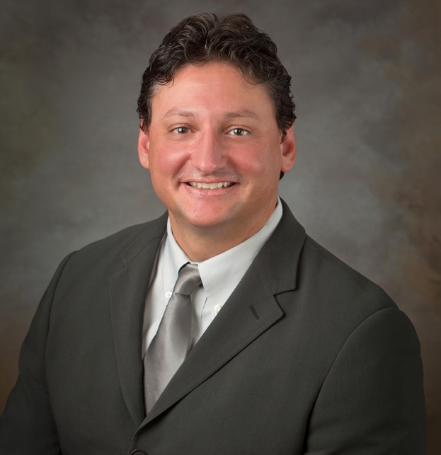 | CV Summary  Dedicated and highly experienced orthopedic surgeon with over 25 years of specialized training in complex adult and pediatric spinal surgeries and pediatric orthopedic conditions. Licensed in Florida, I have performed more than 200 complex surgeries annually and have a decade of experience in providing  medico-legal reports and treating patients with spinal injuries.

Specialty Areas
Pediatric Orthopedic Surgery
- Focus on congenital and developmental spinal deformities and childhood neuromuscular conditions such as Cerebral Palsy.
- Provide single-event, multiple-level surgeries of the lower extremities to correct crouch gait and restore ambulation.
- Routinely implant magnetic growing rods in the young child to correct spinal deformities and guide growth.
Orthopedic Spinal Reconstructive Surgery
- Specializing in spinal deformities, injuries, and reconstructive instrumentation.
- Expertise in multiple surgical implants, including screws, hooks and wires to stabilize most severe spinal injuries.
- Utilize full array of techniques, including spinal vertebrae removal, to address deformities over 130 degrees and congenital vertebrae abnormalities.
Professional Experience
St. Joseph Main and Pediatric Hospitals, Tampa, FL
Department of Pediatric Orthopedic Surgery, 2009–present
- Provided clinical and surgical care for pediatric patients with congenital, developmental, and neurological scoliosis, kyphosis, and other spinal deformities.
- Evaluated and treated adult spinal deformities and traumatic injuries, offering comprehensive care plans tailored to each patient's needs.
Director, Motion Analysis Lab, 2009–present
- Interpreted gait study graphs and video inspections to identify gait abnormalities in disabled children, aiding in the development of effective treatment plans.
- Utilized advanced motion analysis technology to provide objective assessments and improve patient outcomes.
SeaSpine and CoreLink Inc, Carlsbad, CA
Surgical Consultant (2000-present)
- Served as a member of the design committee and quality control, contributing to the development of surgical implants and instruments for spinal surgery.
- Provided expert consultation to ensure the effectiveness and safety of surgical products.
American Osteopathic Academy of Orthopedics
President, Spine Section (2003-2005)
- Chaired the spine section committee, serving as a liaison to newly trained spinal surgeons.
- Developed and supervised annual seminars, providing multiple presentations on advancements in spinal surgery.
- Facilitated knowledge sharing and professional development among orthopedic spine surgeons
Children’s Spine Foundation, Riverside, CA
Primary Surgeon, 2000-2008
- Dedicated volunteer service for the operative and non-operative treatment and care of children with spinal deformities who lack financial means.
- Conducted presentations and reported to the medical advisory team, contributing to the foundation's mission.
- Participated in international outreach programs, including medical missions to the Dominican Republic.
California Children’s Medical Services, Riverside, CA
2000-2008
- Managed satellite clinics for diagnosing and treating disabled children, including those with syndromic conditions and cerebral palsy.
- Provided both surgical and non-surgical care, ensuring comprehensive treatment for pediatric patients.
Inland Empire Spine Center, Riverside, CA
Vice President, 1999-2008
- Managed a team of 70 employees, including 3 contract physicians and 3 physician assistants, ensuring high-quality patient care and efficient operations.
- Directed the attached MRI and physical therapy facility, integrating diagnostic and therapeutic services for comprehensive patient care.
- Oversaw the internal billing department, receiving daily reports from CFO, billing, and office managers to ensure financial stability.
- Focused on treating spinal conditions in injured workers, presenting lectures and seminars on spinal deformities and their impact on the workforce.

Riverside County Medical Center, Riverside, CA
Co-director, Division of Spinal Trauma, 1999-2008
- Evaluated and performed surgical procedures for patients with acute spine injuries, utilizing advanced decompression and stabilization techniques across all regions of the spine.
- Collaborated with a multidisciplinary team to provide comprehensive care and rehabilitation plans for patients with varying degrees of spinal trauma.
- Determined the degree of impairment and paralysis, developing individualized rehabilitation care plans to optimize patient recovery.
Director, Orthopedic Division of Spinal Surgery, 1999-2008
- Managed the evaluation and treatment of patients with both acute and chronic spinal pathologies, providing tailored surgical and non-surgical care.
- Implemented innovative surgical techniques to enhance patient outcomes and reduce recovery times.
- Coordinated care among multidisciplinary teams, ensuring a holistic approach to patient treatment.
Co-director Western University Orthopedic Residency Program, 1999-2008
- Served as Clinical Assistant Professor of Orthopedic Surgery, developing and delivering curriculum for orthopedic training.
- Provided educational lectures and symposiums, sharing expertise and advancements in orthopedic surgery with residents and fellows.
- Supervised surgical training, mentoring residents through complex procedures and fostering professional development.
Qualified Medical Examiner
1999-2008
- Provided medico-legal reports as an Agreed and Independent Medical Examiner, conducting thorough reviews of medical records and detailed examinations.
- Documented disabilities based on deficits in daily living activities, determining claims issues such as causation, apportionment, impairment, work ability, and medical care costs.
- Offered expert opinions that were instrumental in resolving complex legal and medical cases.
Peer Review Physician
2005-2008
- Reviewed treatment recommendations for Cor Vel Medical Provider Network, ensuring appropriateness based on clinical need, record reviews, and special studies.
- Contributed to the overall quality and efficiency of the healthcare system by ensuring patients received appropriate and effective care.

Education
University of Illinois, Champaign, IL (1985–1989)
Bachelor of Science, Biology

Chicago College of Osteopathic Medicine, Midwestern University, Downers Grove, IL (1989–1983)
Doctor of Osteopathic Medicine

- National Board Part I Scores: 95th Percentile
- National Board Part II Scores: 97th Percentile
- National Board Part III Scores: 97th Percentile
- Graduate Class Rank: Upper 10th Percentile

Residency

Orthopedic Surgery: Midwestern University, Chicago, IL (1994-1998)
- Trained across several facilities, including Olympia Fields Hospital, University of Chicago, and Northwestern University.
Fellowships
Reconstructive Spinal Surgery: University of Southern California, Los Angeles, CA (1998-1999)
Pediatric Orthopedic Surgery: Dupont/Nemours Children’s Hospital, Wilmington, DE (2008-2009)

Research Experience
- Siambanes, D., Mather S. “Comparison of Plain X-Rays and CT Scans in Instrumented Posterior Lumbar Interbody Fusions.” Orthopedics, 1998; 21:2.
- Siambanes, D., Miz G. “Treatment of Symptomatic Anterior Cervical Nonunion Utilizing the Rogers Interspinous Wiring Technique.” The American Journal of Orthopedics, 1998; 17:12.
- Siambanes, D. “Preventing Iatrogenic Flat Back Deformity in Lumbosacral Fusions of the Degenerative Spine.” Spineline, 2003; 4:2, 7-15.
- Siambanes, D., Kposawa, A., Michelsen, S. “The Results of Discograms in the Post-Discectomy Patient.” Orthopedics, 2003; 26:8, 77-82.
- Siambanes, D., Butler, E. “The Influence of Backpacks on Non-Specific Low Back Pain in the Adolescent.” Journal of Pediatric Orthopaedics, 2003.
- Siambanes, D. “Are Student Backpacks too Much of a Burden?” Editorial, The Desert Sun, 2/23/2003.
- Siambanes, D. “Preventing Iatrogenic Flat Back Deformity Following Lumbosacral Fusions of the Degenerative Spine.” The Orthopod, 2004; 41:1, 24.
Licensure and Organizations
- Board Certified: Orthopedic Surgery (1999-present)
- Fellow of the American Osteopathic Academy of Orthopedics
- American Osteopathic Association
- American Osteopathic Academy of Orthopedics
- Scoliosis Research Society
- Pediatric Orthopedic Society of North America
Interests
Aviation Enthusiast:
- General Aviation Pilot (land and sea)
- Commercial Pilot (land)
- Instrument Rating
- Tailwheel Rating
Avid Fly Fisherman

