Curriculum Vitae
Ethan Andrew Prince, M.D.

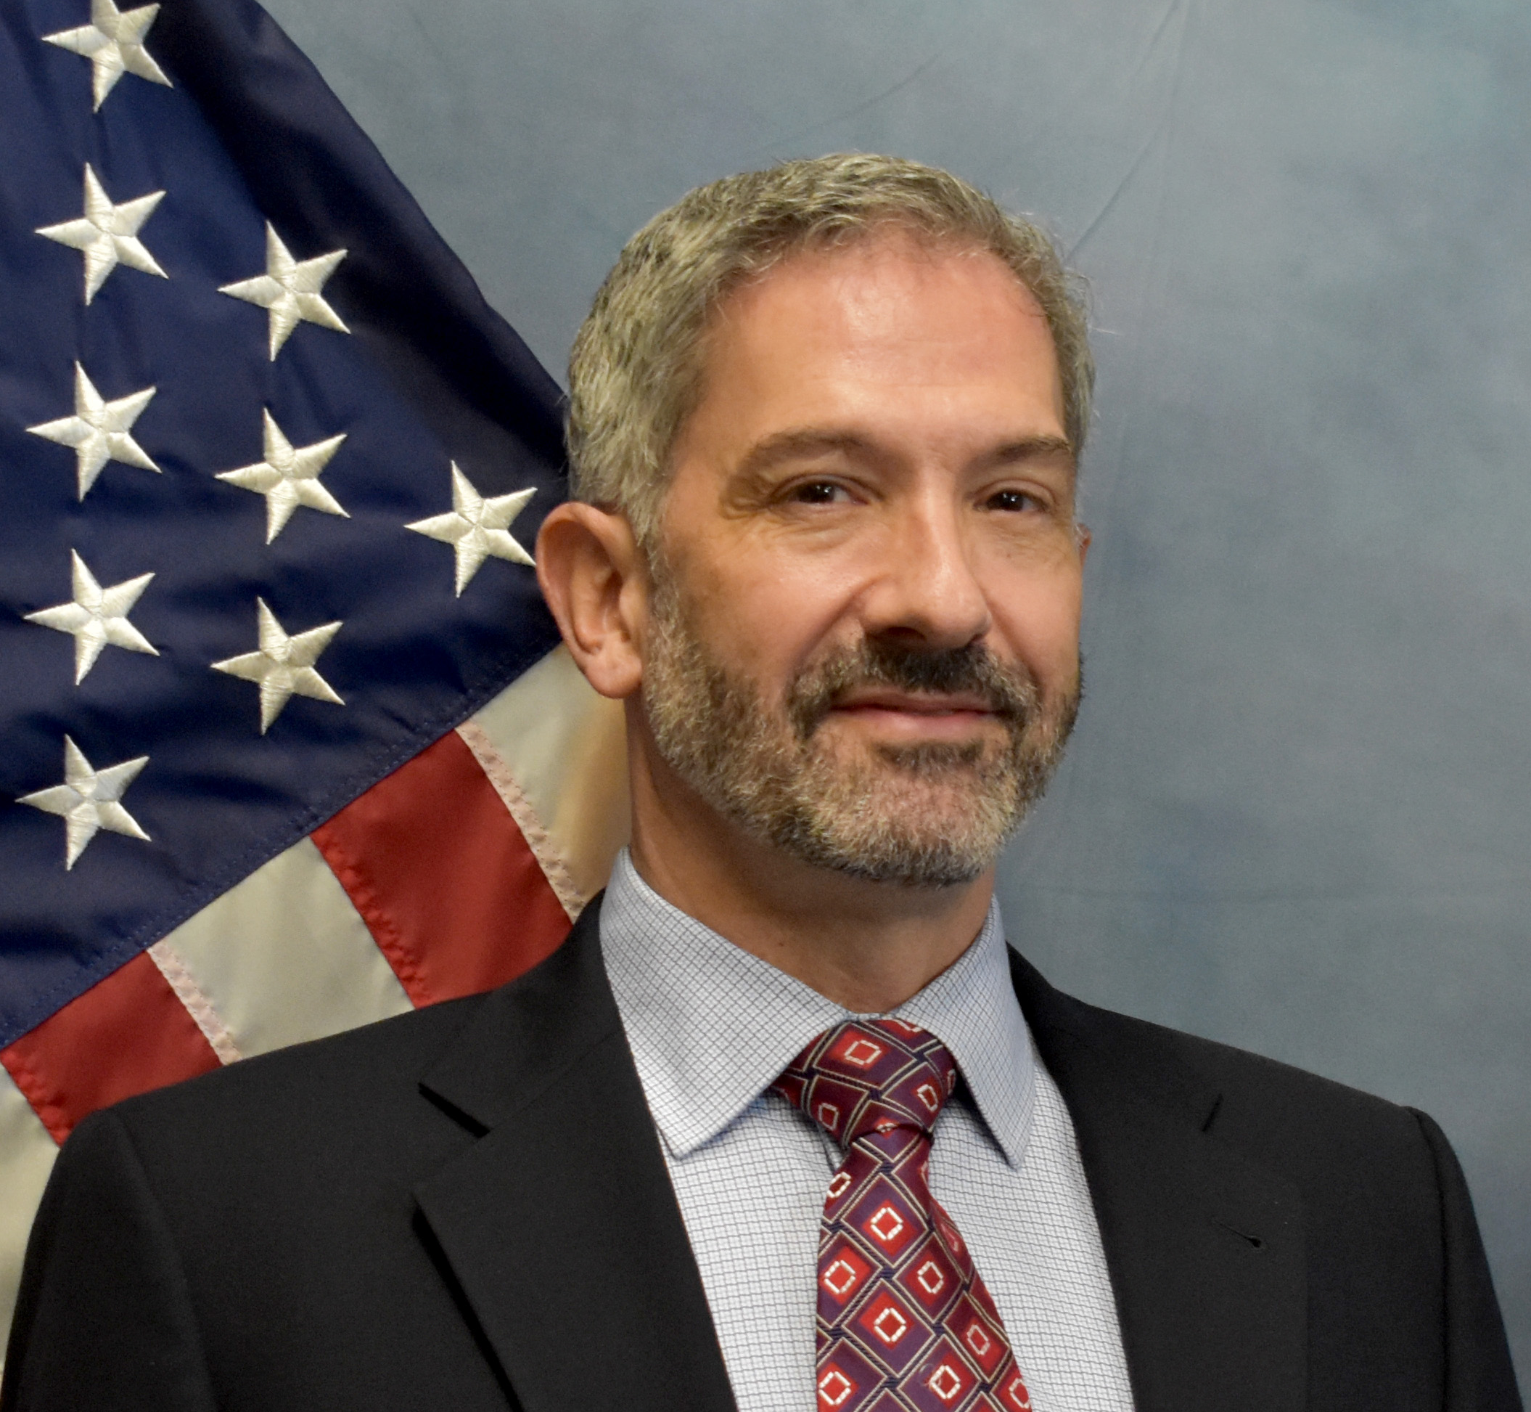

Date Prepared: 1/2/2024

General Personal and Expertise Information:

I am board certified in Vascular and Interventional Radiology and Diagnostic Radiology. I am licensed in the states of Rhode Island, Indiana, Colorado and Connecticut. In addition to general Diagnostic and Vascular Interventional radiology, my practice subspecialties and clinical/academic expertise are in interventional pain medicine, interventional oncology including tumor thermal ablation and embolization, stroke thrombolysis, and management of varicose veins. I have been involved in several clinical research trials, have had numerous articles published in major medical journals, and have been an invited speaker at many medical conferences. I have experience in trial depositions and testimony.

Cell Telephone (401) 787-8227
Email princeethan@hotmail.com

Professional History:

Veteran’s Affairs Medical Center, Providence, Rhode Island. October 2023 – Present.
Duties include interpretation and management of general Diagnostic Imaging (80%; non-vascular imaging, CT, ultrasound, plain film, bone density) and performance of general Interventional Radiology procedures (20%; image guided biopsies, drainages, lumbar puncture, joint aspiration, venous access).

Midstate Radiology Associates, Norwich and Meriden, Connecticut. August 2022 – Present.
Current duties (October 2023 to Present) include weekend moonlighting call coverage for Interventional Radiology. When employed full time (August 2022 to September 2023) responsible for interpretation and management of general Diagnostic Imaging (30%; non-invasive vascular imaging, CT, ultrasound, plain film, bone density) and performance of general Interventional Radiology procedures (70%; images guided biopsies, image guided drainages, vascular embolization, inferior vena cava filter insertion and retrieval, lumbar puncture, joint aspiration, venous access).

Rhode Island Medical Imaging, Providence, Rhode Island. July 2009- May 2021.
Duties included performance general and subspecialty Interventional Radiology procedures (95%; vascular bland/chemo-/radio- embolization, tumor microwave and cyro- ablation, vascular stenting, inferior vena cava filter insertion and retrieval, vascular thrombolysis, lumbar puncture, interventional pain medicine including epidural injections, nerve blocks and nerve ablation, stroke thrombolysis, arterial aneurysm repair, imaging guided biopsies, imaging guided drainages, joint aspiration, venous access, management of venous insufficiency) and interpretation and management of Diagnostic Imaging (5%; non-invasive vascular imaging, CT, ultrasound, plain film, bone density). Assistant/Associate Professor of Diagnostic Imaging responsible for education of medical students, radiology residents, and fellows.

Postgraduate Training:

Internship: July 2000- June 2001
Internal Medicine
Naval Medical Center Portsmouth
Portsmouth, Virginia.

Naval Service: September 2002- June 2004 U.S. Naval Flight Surgeon
Iwakuni, Japan

Residency: July 2004 – June 2008
Diagnostic Radiology
Rhode Island Hospital
Brown University
Providence, Rhode Island

Fellowship: July 2008- June 2009
Vascular and Interventional Radiology
Rhode Island Hospital
Brown University
Providence, Rhode Island

Education:

Undergraduate: September 1989- June 1993
Oberlin College
Oberlin, Ohio
B.A. Neuroscience, with High Honors 1993

Medical School: June 1996– May 2000
Case Western Reserve University
School of Medicine.
Cleveland, Ohio
M.D. 2000

Professional Licenses:

State of Indiana 2002-Present

State of Rhode Island 2004-Present

State of Colorado 2021-Present

State of Connecticut 2022-Present

Awards and Honors:

Graduate of SIR leadership academy April 2013

RSNA Resident/Fellow Research Award June 2008

Chief Resident Jan 2007–Jan 2008
Department of Diagnostic Imaging
Rhode Island Hospital
Brown University

Member of Sigma Xi research society Elected May 1993

High Honors in Neuroscience Awarded May 1993

Academic Appointment:

Associate Professor of Radiology July 2009 – May 2021
Warren Alpert Medical School
Brown University

Hospital Appointments:

Rhode Island Hospital, Providence, Rhode Island July 2009 – May 2021

Miriam Hospital, Providence, Rhode Island July 2009 – May 2021

Women & Infants Hospital, Providence, Rhode Island July 2009 – May 2021

Roger Williams Medical Center, Providence, Rhode Island May 2015 – May 2021

Our Lady of Fatima Hospital, Providence, Rhode Island May 2015 – May 2021

William W Backus Hospital, Norwich, Connecticut August 2022 – Present

Midstate Medical Center, Meriden, Connecticut August 2022 – Present

Veteran’s Affairs Medical Center, Providence, Rhode Island October 2023 - Present

Hospital Committees:
Oncologic Palliative Care Committee 2017 - 2021
Rhode Island Hospital

Interventional Pain Management Credentialing Committee 2018
Rhode Island Hospital

Research Training:

Research Associate October 1994 - May 1996
Massachusetts General Hospital
Department of Radiation Oncology
Boston, MA

Board Certification:

National Board of Medical Examiners Steps I, II, and III 1997, 1998, and 2001

Diagnostic Radiology Boards – ABR Physics (2005; Passed), Written Boards (2006; Passed) and Oral Boards (2008; Passed). Delegate of the American Board of Radiology Certificate No. 55005

Diagnostic Radiology/Vascular and Interventional Radiology 2011. Valid through 3/1/2024

Additional Administrative Duties:

Director of Interventional Radiology May 2015 – May 2021

Charter Care Hospitals, Providence, Rhode Island

Coordinator for development of Local Pre-procedural Hemostasis Guidelines

Lifespan and Charter Care Hospitals, Providence, Rhode Island

Coordinator for development of Local Peri-procedural Prophylactic Antibiotic Guidelines

Lifespan and Charter Care Hospitals, Providence, Rhode Island

Original Publications in Peer-Reviewed Journals

- Arepally A, Chos J, Katz SC, Jaroch D, Kolli KP, Prince E, Liddell RP. Pressure-enabled drug delivery approach in the pancreas with retrograde venous infusion of lipiodol with ex vivo analysis. Cardiovasc Intervent Radiol. 2021 Jan;44(1):141-149.

- Chai LF, Prince E, Pillarisetty VG, Katz, SC. Challenges in assessing solid tumor response to immunotherapy. Cancer Gene Ther. 2020 Aug;27(7-8): 528-538.

- Katz SC, Moody AE, Guha P, Hardaway JC, Prince E, LaPorte J, Stancu M, Slansky JE, Jordan KR, Schulick RD, Knight R, Saied A, Armenio V, Junghas RP. HITM-SURE: hepatic immunotherapy for metastases phase Ib anti-CEA CAR-T study utilizing pressure enabled drug delivery. J Immunother Cancer. 2020 Aug;8(2): e001097.

- Katz SC, Guha P, Hardaway J, Prince E, Cunetta M, Moody A, Armenio V, Wang LJ, Espat NJ, Junghans RP. HITM-SIR: Phase 1b trial of intra-arterial chimeric antigen receptor modified T cell therapy and selective internal radiation therapy for CEA liver metastases. Cancer Gene Therapy 2020 May;27(5):341-355.

- Hardaway JC, Prince EA, Arepally A, Katz SC. Regional infusion of chimeric antigen receptor T cells to overcome barriers for solid tumor immunotherapy. J Vasc Interv Radiol 2018 Jul;29(7)1017-1021.

- Chung M, Dubel GJ, Noto RB, Yoo DC, Baird GL, Prince EA, Murphy TP, Haaga TL, Ahn SA. Acute Lower Gastrointestinal Bleeding: Temporal Factors Associated with Positive Angiography following 99mTc-RBC Scans. Am J Roentgenol. 2016 Jul; 207:170-176

- Naeem M, McEnteggart GE, Murphy TP, Prince E, Ahn S, Soares G. Fenoldam for the prevention of contrast-induced nephropathy (CIN) – do we need more trials? A meta-analysis. Clinical Imaging 2015 Sep-Oct;39(5):759-64.

- Angle JF, Prince EA, Matsumoto AH, Lohmeier TE, Roberts AM, Misra S, Razavi MK, Katholi RE, Sarin SN, Sica DA, Shivakumar K, Ahrar K. Proceedings from the Society of Interventional Radiology Foundation research consensus panel on renal sympathetic denervation. J Vasc Interv Radiol 2014 Apr; 25:497-509.

- Jaffan AA, Prince EA, Hampson CO, Murphy TP. The perclose technique in percutaneous endovascular aortic repair: a systematic literature review and meta-analysis. Cardiovasc Intervent Radiol. 2013 Jun;36(3)567-77.

- Prince EA, Murphy TP, Hampson CO. Catheter based arterial sympathectomy: hypertension and beyond. J Vasc Interv Radiol. 2012 Sept;23(9):1125-1134.

- Prince EA, Jayaraman MV, Schirmang TC, Haas RA. Angiographically documented hemorrhagic conversion of a left MCA embolic stroke during intraarterial thrombolysis. J Neurointerv Surg 2011 Sept; 3(3):246-248.

- Worth PJ, Conklin P, Prince E, Singh AK. Migration of retained right ventricular epicardial pacing wire into the pulmonary artery: A rare complication after heart surgery. J Thorac Cardiovasc Surg. 2011 Sept; 142(3): e136-8.

- Prince EA, Soares GM, Silva M, Taner A, Ahn SH, Dubel GJ, Jay BS. Impact of laser fiber design on outcome in endovenous ablation of lower extremity varicose veins: results from a single practice. Cardiovasc Intervent Radiol. 2011 Jun;34(3):536-41.

- Atalay MK, Prince EA, Pearson CA, Chang KJ. The prevalence and significance of non-cardiac findings at cardiac MRI. AJR 2011 Apr:196; W387-W393.

- Prince EA, Jayaraman MV, Haas RA. The use of self expanding stents in the treatment of cerebrovascular occlusions. A brief report. J Vasc Interv Radiol 2010 Nov; 22(11): 1755-1759.

- Prince EA, Ahn SH, Dubel GJ, Soares GM. An investigation of the relationship between energy density and EVLA success: Does energy density matter? J Vasc Interv Radiol. 2008 Oct;19(10): 1449-1453

- Prince EA, Murphy TP, Dhangana R, Soares GM, Ahn SH, Dubel GJ. Evaluation and management of PAD patients by interventional radiologists: current practices. J Vasc Interv Radiol. May 2008 May;19(5): 639-644.

- Atalay MK, Prince EA, Cronan JJ. Referrals to a dedicated cardiac MRI service: Who sends what? J Am Coll Radiol. 2008 May;5(5):638-43.

- Prince EA, Yoo DC, DeLellis RA, Mayo-Smith WW. CT and PET appearance of a biopsy proven pigmented “black” adrenal adenoma in a patient with lung cancer. Clin Radiol. 2007 Dec;62(12):1229-1231.

- Zietman AL, Prince EA, Nakfoor BM, Park JJ. Androgen Deprivation and Radiation Therapy: Sequencing Studies using the Shionogi in vivo Tumor System. Int J Radiat Oncol Biol Phys. July 1997;38(5):1067-70

- Zietman AL, Prince EA, Nakfoor BM, Shipley WU. Neoadjuvant Androgen Suppression with Radiation in the Management of Locally Advanced Adenocarcinoma of the Prostate: Experimental and Clinical Results. Urology. Mar 1997;49(3A):74-83.

- Zietman AL, Prince EA, Nakfoor BM, Gerwick LE. The Effects of Androgen Deprivation and Radiation Therapy on an Androgen-sensative Murine Tumor: an in vitro and vivo Study. Cancer J Sci Am. 1997 Jan-Feb;3(1):31-36.

Non-Peer Reviewed Publications:

1. Ahn SA, Prince EA, Dubel G. Basic neuroangiography: review of technique and perioperative patient care. Sem Intervent Radiol. 2013 Sep; 30:225-233.

3. Prince EA, Ahn SA. Basic vascular neuroanatomy of the brain and spine: what the interventional radiologist needs to know. Sem Intervent Radiol. 2013 Sep; 30:234-239.

4. Prince EA, Ahn SA. Interventional management of vertebral body metastases. Sem Intervent Radiol. 2013 Sep;30: 278-281.

5. Prince EA, Ahn SA, Soares GM. Intra-arterial stroke management. Sem Intervent Radiol. 2013 Sep;30: 282-287.

6. Ahn SA, Prince EA, Dubel G. Carotid artery stenting: review of technique and update of recent literature. Sem Intervent Radiol. 2013 Sep;30: 288-296.

7. Iannuccilli J, Prince EA, Soares G. Interventional spine procedures for management of chronic low back pain – a primer. Sem Intervent Radiol. 2013; 30: 307-317.

8. Ahn SH, Prince E. Tuberous Sclerosis Complex. Images in Medicine. Med Health RI. 2010 Jun; 93(6): 189-190.

9. Prince EA, Dubel GJ. In Zagoria RJ, Mayo-Smith WW, Fielding JR (authors) Genitourinary Radiology; Case Review Series, Second Ed. Elsevier, New York. 2006.

10. Zietman AL, Prince EA. In Budach V, Dinges S (Eds). Radiation Therapy with and Without Neoadjuvant Androgen Suppression in the Management of T3-4 Adenocarcinoma of the Prostate. Locally Advanced Prostate Cancer. Diagnostic and Therapeutic Challenges. Blackwell Publishers. 1996.

Abstracts:

1. Pouw M, Albright J, Kozhimala M, Baird G, Nguyen V, Prince E, Scappaticci A, Ahn SH. Imaging triage of lower gastrointestinal bleed: assessing utility of selected contrast phases of multiphasic CTA. Society of Interventional Radiology Annual Meeting. Austin, Texas. March 2019.

2. Gitelmaker D, Bierwirth RJ, Prince E, Epstein A, Young B. A rare case of ischemic colitis due to an inferior mesenteric vascular anomaly leading to steal phenomenon. The World Congress of Gastroenterology, Orlando, Florida. October 2017.

3. Scappaticci AA, Soares G, Prince EA, Muratore C. Alterations of vagus nerve electrophysiology in response to venoplasty; towards a non-hemodynamic explanation for clinical improvement following jugular venoplasty in patients with multiple sclerosis. Presented at Society of Interventional Radiology Annual Meeting. New Orleans, Louisiana. April 2013.

4. Ahn SH, Van Zandt B, Prince EA, Gill G, Soares G, Dubel G, Marshall DS, Reddy S. 504 cases of non-GSV EVLA: long term outcomes and comparison with GSV EVLA. Presented at Society of Interventional Radiology Annual Meeting. New Orleans, Louisiana. April 2013.

5. Ahn SH, Prince EA, Mahajan N, Van Zandt B, Soares G, Dubel G, Marshall DS, Reddy S. EVLA of lower extremity superficial venous reflux disease: relationship between long-term recanalization rates and energy density. Presented at Society of Interventional Radiology Annual Meeting. New Orleans, Louisiana. April 2013.

6. Ahn S.H., Gill G., Prince E.A., Soares G., Van Zandt B., Marshall D.S., Reddy S. Endovenous Laser Ablation (EVLA) Performed with 1470 nm Laser: Long Term Outcomes and Comparison with 980 nm Laser. Presented at Society of Interventional Radiology Annual Meeting. New Orleans, LA. April 2013.

7. Abromovici G, Ahn AH, Prince EA, Dubel GJ, Soares GM. Endovenous laser ablation of the great saphenous vein: does laser tip position below the superficial epigastric vein affect its patency? Oral abstract presentation at Society of Interventional Radiology Annual Meeting. Tampa, Florida. March 2010.

8. Prince EA, Ahn SH, Dubel GJ, Nokes M, Soares GM, Khan N. Evolution of a vein practice. Oral and Electronic Poster Presentation at International Society of Endovascular Therapy, Hollywood, Florida. January 2007.

9. Atalay MK, Prince EA, Mayo-Smith W, Cronan JJ. Exam duration and PACS volumes in cardiac MR: When is enough enough? North American Society of Cardiovascular Imaging. Las Vegas, Nevada. September 2006

10. Prince EA, Zietman AL, Nakfoor BM, Shipley WU. Permanent Tumor Erradication by Radiation is Enhanced by Prior Androgen Withdrawal. Radiation Research Society, Chicago, Illinois. March 1996.

11. Prince EA, McCormick CA. A Presumed Acoustic Pathway from the Ear to the Telencephalon in the Osteoglossomorph Teleost Xenomystus nigri, the African Knifefish. National Meeting of the Society for Neuroscience, Washington D.C. October 1993.

Invited Presentations:

Regional

1. Twin Reverse Arterial Perfusion: Interventional Management. Grand Rounds presentation to the faculty, trainees, and staff of the department of Maternal Fetal Medicine at Women & Infants Hospital, Providence, Rhode Island. October 2019.

2. Evidence Based Approach to Sub-Massive Pulmonary Emboli. Providence, Rhode Island. March 2018.

3. Interventional Radiology and Women’s Health. Brown University Interventional Radiology Symposium. Providence, Rhode Island. October 2013

4. Basic Clinical Approach to the patient with Back Pain – When to Refer to a Specialist. Coast Medical Annual Continuing Medical Education Retreat. Warwick, Rhode Island, September 2013.

5. Transluminal Sympathectomy; advances in interventional radiology, hypertension, and dysautonomia. New England Roentgen Ray Society Meeting. Boston, Massachusetts. May 2013.

6. Carotid ultrasound: Pearls and Pitfalls. New England Roentgen Ray Annual Ultrasound Course. Waltham, Massachusetts. March 2013

7. Transluminal Sympathectomy; advances in interventional radiology, hypertension, and dysautonomia. New England SIR. Boston, Massachusetts. February 2013.

8. Interventional Pain Management. Contemporary Diagnostic and Interventional Radiology Continuing Medical Education course. Providence, Rhode Island. November 2012.

9. IR; your partner in emergency care. Sturdy Memorial Hospital. Attleboro, Massachusetts. October 2012.

10. Endovascular treatment of acute deep vein thrombosis. Coastal Medical Grand Rounds on Imaging. Warwick, Rhode Island. October 2011.

11.Introduction to Interventional Radiology. Coastal Medical Annual Continuing Medical Education Retreat. Warwick, Rhode Island. September 2010.

National

1. IR Domain: Palliative Care. Society of Interventional Radiology Annual Meeting. Austin, Texas. March 2019.

2. Coordinator and Presenter Renal Denervation Categorical Course. Society of Interventional Radiology Annual Meeting. Atlanta, Georgia. March 2015.

3. Coordinator of Embolic Protection Devices Hands-on Workshop. Society of Interventional Radiology Annual Meeting. Atlanta, Georgia. March 2015.

4. Transluminal neuromodulation outside of the Kidneys. Presented at Society of Interventional Radiology Annual Meeting. San Diego, California. March 2014.

5. Coordinator of Renal Denervation Categorical Course; Transluminal Neuromodulation: Current achievements and future directions. Society of Interventional Radiology Annual Meeting. San Diego, California. March 2014.

6. Coordinator of Embolic Protection Devices Hands-on Workshop. Society of Interventional Radiology Annual Meeting. San Diego, California. March 2014.

7. Presenter and Panelist at the Trauma Embolization Workshop. Society of Interventional Radiology Annual Meeting. San Diego, California. March 2014.

8. Panelist and Presenter at the Society of Interventional Radiology Research Consensus
Panel Meeting. Reston, Virginia. October 2013.

9. Invited panelist, Faculty, and Presenter at the Society of Interventional Radiology Catheter Lysis of Thromboembolic Stroke (CLOTS) course. Dallas, Texas. October 2012.

10. Role of intra-arterial therapy in the management of acute ischemic stroke. Invited speaker and panelist in the ‘Stroke’ categorical course presented at the Society of Interventional Radiology Annual Meeting. San Francisco, California. March 2012.

11. Controversies in laser ablation. Panelist and moderator of an expert panel on the treatment of lower extremity venous insufficiency using laser ablation. 11th annual meeting of the American Society of Laser Medicine and Surgery. Grapevine, Texas. April 2011.

Teaching Roles:

Administrative

Co-coordinator of Brown Medical Student Interest Group 2009-2011

Responsible for creating, coordinating and providing an annual curriculum introducing medical students to radiology.

Alpert School of Medicine at Brown University

1. Biomed 629
General Introduction to Radiology; Faculty
Alpert Medical School of Brown University 2009 – 2021

General introduction to Diagnostic and Vascular Interventional Radiology for third- and fourth-year medical students, with both clinical observation and didactic educational sessions. I teach medical students during their rotation through the Interventional Radiology division using a combination of active case discussions and topical lectures.

2. Biomed 633
Vascular and Interventional Radiology Elective; Faculty
Alpert Medical School of Brown University 2009 – 2021

Focused education in Interventional Radiology for third- and fourth-year medical students. I teach students during their rotation through the Interventional Radiology division using a combination of active case discussions and topical lectures.

3. Biomed Rad 6310
Sub-Internship in Interventional Radiology; Faculty
Alpert Medical School of Brown University 2018 – 2021

Advanced education for third- and fourth year considering careers in Interventional Radiology. Course is available to both visiting medical students and those from Alpert School of Medicine. Provides students with the opportunity to gain in-depth knowledge of the daily responsibilities associated with Interventional Radiology fellowship/residency. I teach medical students during their rotation through the Interventional Radiology division using a combination of active case discussions and topical lectures.

4. Biol 6692
Introduction to Interventional Radiology; Faculty
Alpert Medical School of Brown University 2018 – 2021

Evening classroom-based lecture series supplementing the hospital based Interventional Radiology elective. I have provided one hour lectures each year that this course has been offered.

5. Longitudinal Integrated Clerkship; Faculty
Alpert Medical School of Brown University 2018 – 2021

Introduction to Diagnostic and Vascular Interventional Radiology for third-year medical students going into Primary Care & who will obtain Master of Science in Population Medicine [ScM] & will have dual degree MD-ScM). I have provided one-hour lectures on Interventional Radiology each year that this course has been offered.

Hospital Teaching

1. Brown Radiology Residency; Faculty
Rhode Island Hospital 2009 – 2021

Provide 3-5 one-hour lectures per year on topics related to Interventional Radiology.

2. Internal Medicine Residency
Roger Williams Medical Center 2011 – 2021

Provide residents with annual one-hour lectures covering the scope of Interventional
Radiology procedures with a focus on the appropriate use of interdepartmental referrals.

