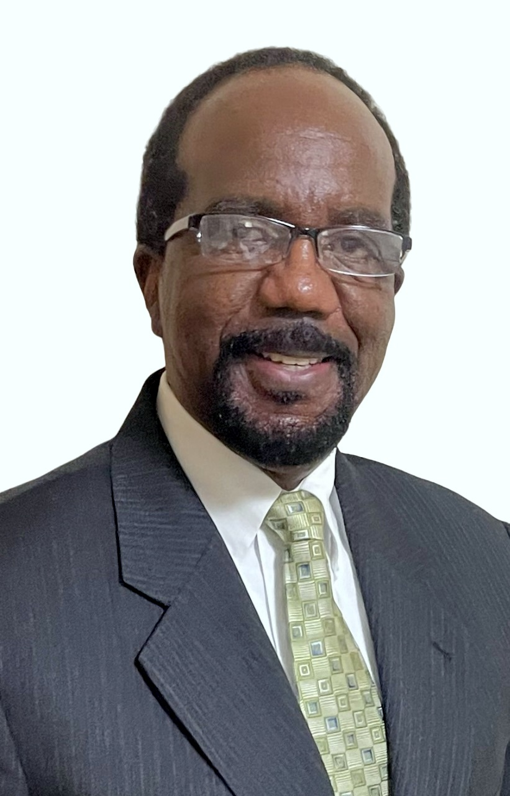
Anthony G. Stanley, MD

Address: 282 NE 143rd Street
Miami, Florida 33161
Cell Phone:(786)548-2284
Fax:(305)635-2261
E-mail: tstanleymd@gmail.com

Internal Medicine Physician in active clinical practice. 30+ years of clinical experience in both Emergency Room and Urgent Care settings. Holder of 2 US Medical Device Patents, specializing in performance safety in foreign body removal, measuring wound site damage, and suturing.

PROFESSIONAL EXPERIENCE

Attending, Emergency Dept. March 2011 - Present
Baptist Health of South Miami Hospital
South Miami, Fl

Criti-Care Urgent Care, Inc. December 2010 - Present
South Miami, Fl

Contract Medical Director
Kizen Medical Services December 2010 - May 2013
Miami, FL

Attending, Emergency Dept. December 2002 - June 2011
Homestead Hospital
Homestead, Fl

Attending July 2008 - March 2011
Mercy Hospital
Miami, Fl

Attending August 1998 - March 2011
Homestead Hospital
Homestead, Fl

Medical Director August 2008 – December 2010
MediGo Urgent Care
Miami Beach, Fl

Medical Director January 2007 - August 2007
Helen B. Bentley Family Health Center, Inc.
Miami, Fl

HIV Specialist/Internal Medicine Attending January 2001 - July 2006
North Dade Health Center
Opa-Locka, Fl

Attending
Jackson Memorial Hospital ER/Urgent Care Center August 1998 - July 2006
Miami, Fl

Hospitalist September 2000 - May 2003
Physicians Health Care Group, Inc.
Homestead, Fl

HIV Specialist/Internal Medicine Providing Primary Care December 1999 - January 2001
Immune Care, LLC
Miami Shores, Fl

Hospitalist August 1999 - December 1999
Homestead Hospital-Inter/Med In-House Physician Services
Homestead, Fl

Worker’s Compensation Physician-Certified June 1999 – June 2001
Daniel & Yeager Physician Placement Services
Fort Lauderdale, Fl

EDUCATION

Fellowship, Geriatric Medicine July 1997 - June 1998
University of Miami& Jackson Memorial Hospital.
Miami, Fl

Residency July 1994 – June 1997
University of Miami-Jackson Memorial Medical Center Program (Internal Medicine)
Miami, Fl

MD August 1990 – May 1994
Rutgers, (UMDNJ)-New Jersey Medical School
Newark, NJ

BS in Medicine August 1981 – May 1983
University of Florida, Physician Assistant Program
Gainesville, Fl

BS August 1975 – June 1979
University of Florida
Gainesville, Fl

CURRENT CERTIFICATIONS & LICENSES
Board Certified - Internal Medicine
Board Eligible - Geriatric Medicine
National Commission on Certification of Physician Assistants (NCCPA).
NCCPA- Specialty Certification in Family Practice
Basic Life Support
Pediatric Advanced Life Support
Advanced Cardiac Life Support

Florida Board of Medicine License # ME77954
New York Board of Medicine License # 320228
Medical Doctor Expert Witness Certificate # MEEW10254
Physician Assistant Fla. License #PA2178

HONORS & AWARDS
Nominee Physician of the year, Baptist Health of South Florida Outpatient services 2018

CURRENT PROFESSIONAL ORGANIZATIONS
American Medical Association

PATENTS
FDA Registered Medical Devices:
US 9,943,971 B2
US 2016/0235498 A1

