Medical career:
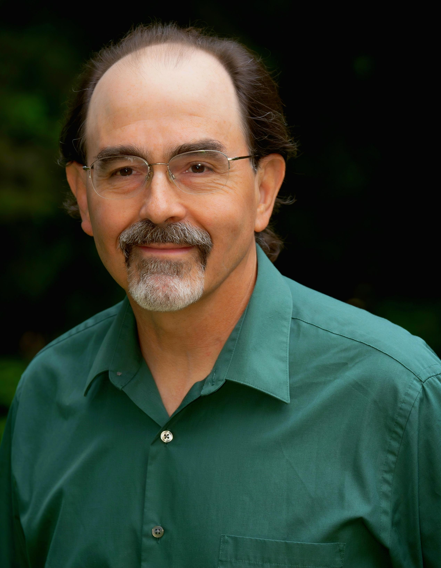

Thomas A Rafalski MD
  - Internal medicine/hospitalist

Summary
Internal Medicine physician & Hospitalist in Western Oregon for over 38 years, skilled and experienced at making sense of complex medical cases. My practice focus has been inpatient medicine and critical care in small community hospitals, often in a resource limited setting.

Contact
Cell Phone: 541-905-4574
E-mail: trafalsk@samhealth.org
Mail address: PO box 1034
Yachats, OR 97498
Board certified Internal Medicine in Oregon since 1988.
Expert witness and review focusing on complex inpatient internal medicine/hospitalist cases 2012 to present. Experience in providing deposition testimony and written reports.
Currently employed as hospitalist at Samaritan Pacific Communities Hospital (Newport, OR) 2014 to present.
Founded/established the Hospitalist Program at Samaritan Albany General Hospital (Albany, OR) in 2003. Medical director and full-time hospitalist at that institution 2003-2014.
Recently Chief of Staff at Samaritan Pacific Communities Hospital (Newport, OR), coastal representative to Samaritan Critical Care Committee, past service on numerous other hospital committees at Samaritan Albany and Newport (OR) hospitals over the course of my career. Extensive experience providing medical staff peer review throughout my career.
Internal medicine/primary care and hospital medicine Albany Internal Medicine Group (Albany, OR) 1988-2003.
HIV specialist: Served as the primary HIV consultant and care provider in Linn, Benton, and Lincoln Counties (OR) 1991-2010.
Many years of experience providing clinical teaching for medical students and residents who rotate through our hospital wards.

education:
Medical internship and residency: University of Cincinnati, Internal Medicine, 1985-1988
Medical school: Indiana University School of Medicine, M.D., 1981-1985
Undergraduate education: University of Notre Dame, B.S., 1977-1981

community service:
Public speaker for HIV education 1991-2010, associated with Valley AIDS Information Network, Corvallis, OR.
Albany (OR) InReach Free Clinic for many years while practicing in Albany.
Volunteer Lincoln Co (OR) Medical Reserve Corps 2020 to present, volunteering at COVID vaccine clinics.

publications:
As I have spent my entire career in small community hospitals rather than academic centers, I have not pursued a pathway of research and publication. However, I have been on the front lines providing initial care of several reportable novel cases, with these examples:
A Series of Lead Poisonings Due to Contaminated Methamphetamine: https://pubmed.ncbi.nlm.nih.gov/2296138/
Severe Methemoglobinemia and Hemolytic Anemia from Aniline Purchased as 2C-E, a Recreational Drug: https://www.cdc.gov/mmwr/preview/mmwrhtml/mm6105a1.htm
Case Report of Multisystem Inflammatory Syndrome in Adults (MIS-A): A 31 Year Old Man with Fever, Rash, and Cardiac Symptoms 6 Weeks Following SARS-CoV-2 Infection, Successfully Resuscitated Following Cardiac Arrest: https://amjcaserep.com/abstract/full/idArt/938127

Updated 1/26/2026

