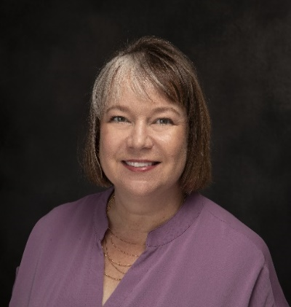
Jill Baldwin, RN, MSN, APRN

12914 Observation Circle, Ste. 102
Louisville, KY 40243

Jill.Baldwin@NPLegalSoultions.com
(502) 321 – 7440 (cell)

Current Employment

Family Nurse Practitioner 2023 - Present

Hope Health Clinic LaGrange, KY

Family Nurse Practitioner 2016 - Present
Genesis One Health Louisville, KY

Licensures/Certifications
Walsh Research Institute Certification, 2025

Board Certified Family Nurse Practitioner, 1998 – Present

Registered Nurse, 1993 - Present

Education

2024 – Institute for Functional Medicine (Certification to be completed 12/2025)

1997 – MSN, APRN University of Cincinnati

1995 – BSN University of Cincinnati

1993 – Diploma of Nursing Christ Hospital School of Nursing

Past Experience

Emergency Room Nurse Practitioner 2010 - 2021
Southern Emergency Medical Specialists Louisville, KY

Emergency Room Nurse Practitioner 2010 – 2011
Louisville Emergency Medical Associates Louisville, KY

Administrator/Family Nurse Practitioner 2007 - 2010
Operation Care Shelbyville, KY

Family Nurse Practitioner 2005 – 2007
Shalom Health Care Center Indianapolis, IN

Emergency Room Nurse Practitioner 2001 – 2005
Midwest Medical Management Shelbyville, IN

Family Nurse Practitioner 2004 - 2005
Homeless Initiative Program Indianapolis, IN

Independent Family Nurse Practitioner 2000 - 2005
NP Solutions, LLC Shelbyville, IN

Family Nurse Practitioner 1998 – 2000
Family Health Services Rushville, IN

Registered Nurse 1993 - 1998
The Christ Hospital Cincinnati, OH

Invited Presentations
- Current Update: Essential ER Management of Stroke, Pulmonary Embolism, Myocardial Infarction, and Sepsis. (APR 2021) American Association of Legal Nurse Consultants annual conference, online forum

- Diabetes Awareness. (NOV 2020) YKK Corporation of America, online forum

- On the Frontline of COVID: an ER Perspective. (AUG 2020) YKK Corporation of America Health and Safety Conference, online forum

- On the Frontline of COVID: an ER Perspective. (JUL 2020) YKK Corporation of America, Board of Directors, online forum

- Heart Disease Prevention. (MAY 2020) YKK Corporation of America, online forum

- Introduction to Teach To Transform. (APR 2017) 360 Mission Conference, Birmingham, AL

- Nurse Practitioners and Physician Assistants: Are They the Same Thing? (MAY 2005) Butler University, Indianapolis, IN

- Advanced Orthopedic Assessment. (DEC 2005) Major Hospital Healthcare System, Shelbyville, IN

- Preventative Care in Primary Care. (AUG 1999) University of Cincinnati, Cincinnati, OH.

Teaching Experience
Adjunct Professor of Nursing 2010 – 2011
Indiana Wesleyan University Louisville, KY

Assistant Professor of Nursing 2001 – 2002
University of Cincinnati

Precepted Nurse Practitioner students from Bellarmine University (2007 – 2009), Spaulding University (2007 – 2009), Indiana Wesleyan University (2006 – 2007), Ball State (1998 – 2000), and University of Indianapolis (1998 – 2000).

Leadership
Applying Functional Medicine in Clinical Practice Scholarship, 2024

Board of Directors for National Association of Free and Charitable Clinics, Treasurer, 2009
– 2011

Sigma Theta Tau Nursing Honor Society for community service, 1999

Ohio Board of Nursing Practice Committee, 1993 – 1994

Volunteer Service
Nurse 2024
Havanna, Cuba

Family Nurse Practitioner 2023
Hope Health Clinic LaGrange, KY

Team Leader/Nurse Educator 2014 – 2018
Teach To Transform Ecuador and Peru

Family Nurse Practitioner 2004
Indianapolis Police Department Tegucigalpa, Honduras

Family Nurse Practitioner 2002 - 2003
One Mission Society Latacunga, Ecuador

Family Nurse Practitioner 1999
Rensselear Free Community Clinic Shelbyville, IN

Professional Organizations
Neuroimmune Institute, 2024 – P

American Academy of Nurse Practitioners, 1998 – P

Kentucky Association of Nurse Practitioners and Nurse Midwives, 2007 - P

American Association of Legal Nurse Consultants, 2019 - 2023

Languages
Intermediate Spanish speaker

Updated 8/2024

