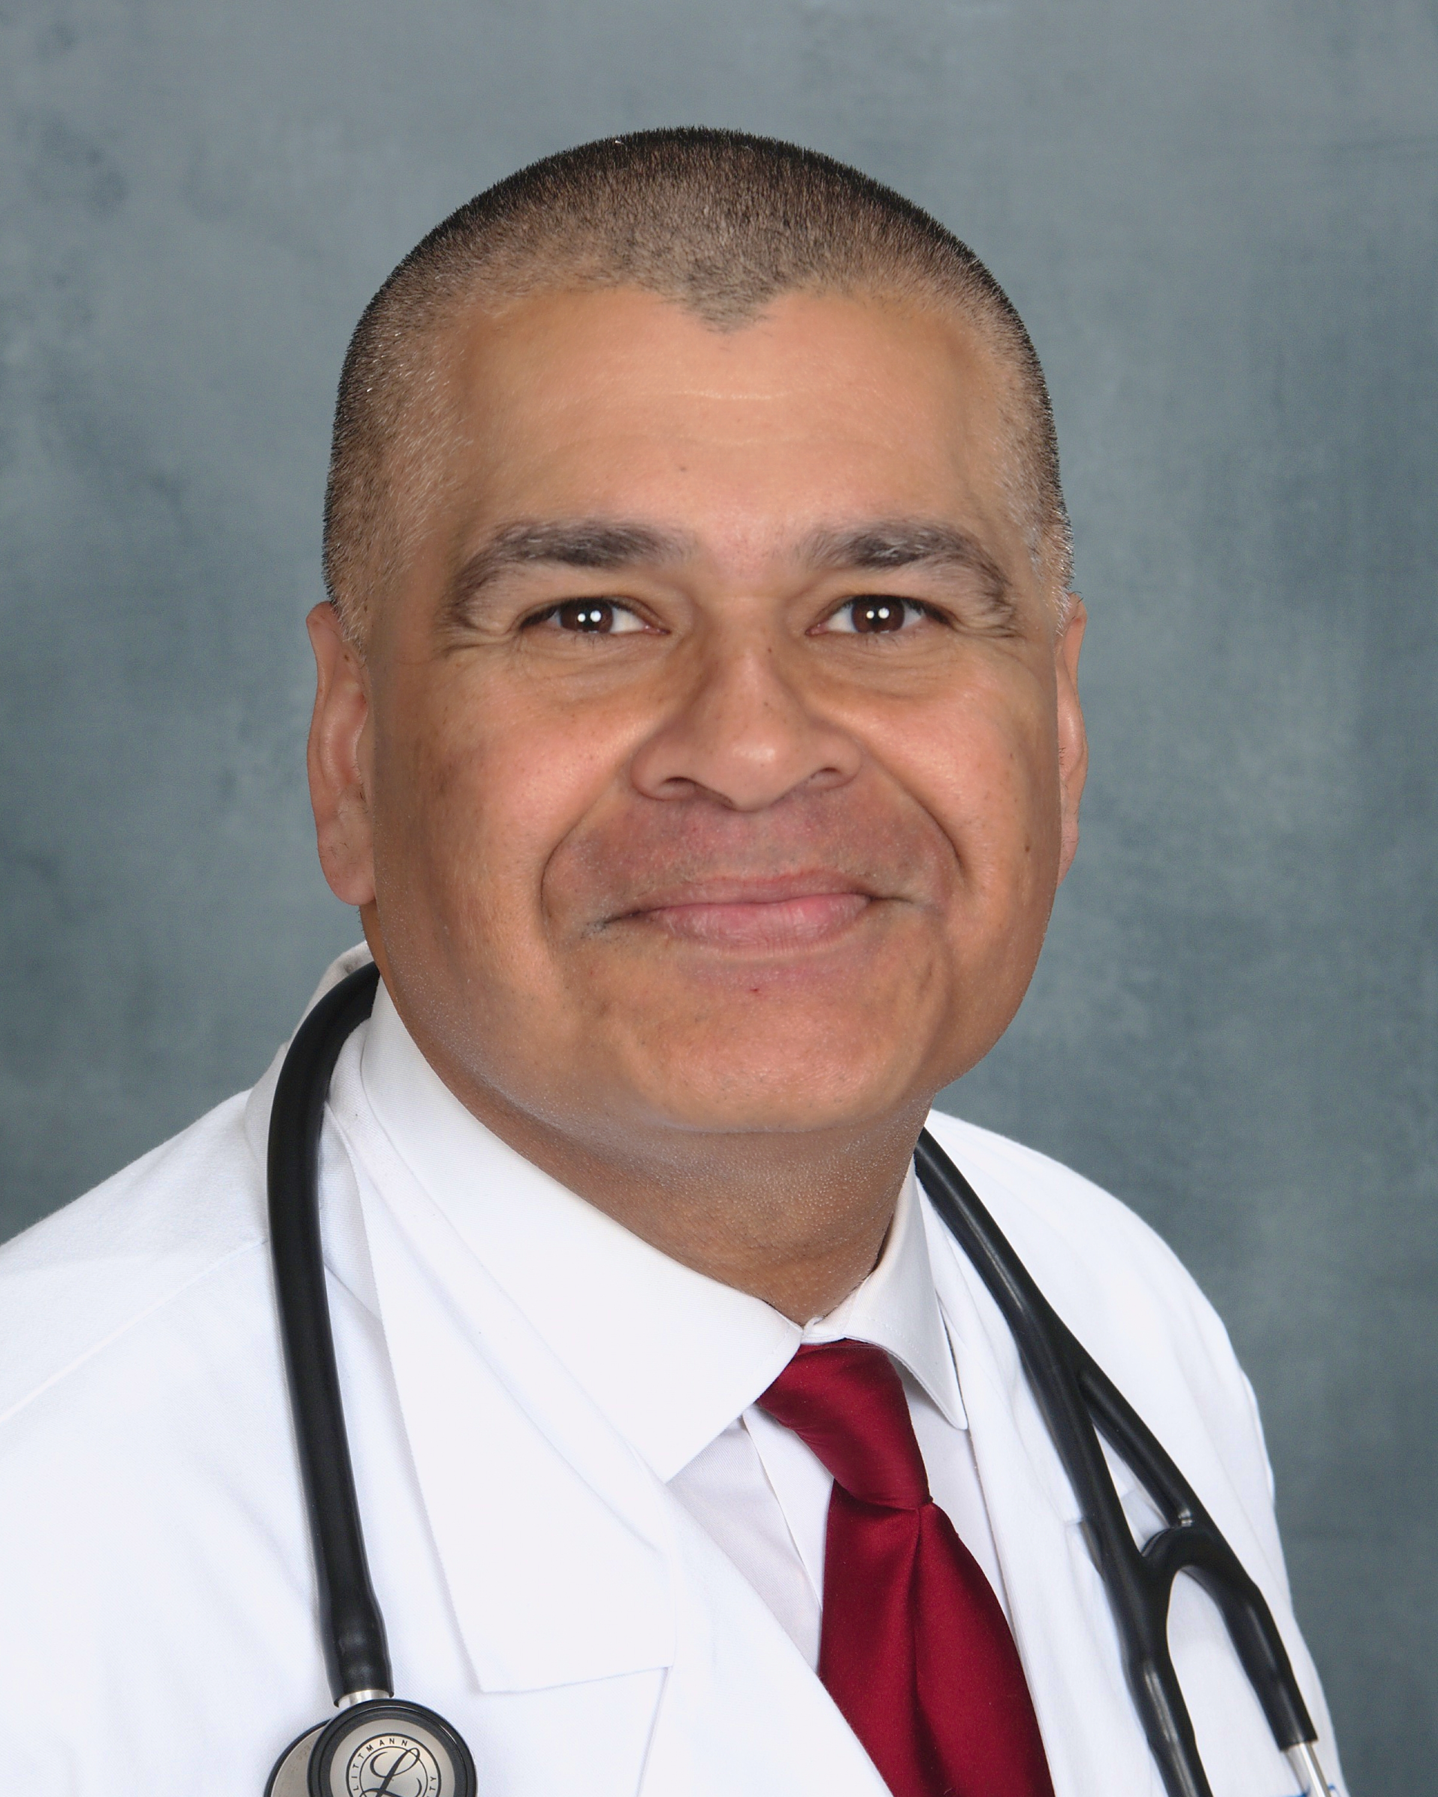
Curriculum Vitae
Niraj Govil, MD, MPH
1 W. Parsonage Way
Manalapan, NJ 07726
fpng820@ gmail.com
(732) 378-9651

CURRENT

1/2019- present Telemedicine, Online Care Group, Family Medicine

06/2018- present Urgent Care Family Physician, AMCARE, Fairborn, Ohio

12/2017-present Telemedicine, Keeps Medical Group

07/2017-present Faculty, School of Aerospace Medicine, United States Air Force, Wright-Patterson Air Force Base. Division Chief for the United States Air Force Aeromedical Consult Service.

2007-present Senior Ranking Physician, Credentialed and Privileged, United States Air Force

LICENSURE AND CERTIFICATION

2017 American Board of Preventative Medicine, Diplomate, Occupational
Medicine
2016 American Board of Preventative Medicine, Diplomate, Aerospace
Medicine
1999 American Board of Family Medicine, Diplomate
2018 State of Mississippi, Medical License
2017 State of Ohio, Medical License
1997 State of New Jersey, Medical License

EDUCATION & TRAINING

2013-2015 Residency in Aerospace Medicine, United States Air Force
School of Aerospace Medicine, Wright-Patterson
Air Force Base, OH
2012-2013 MPH, Rutgers University/John's Hopkins University- School of
Public Health
1996-1999 Residency in Family Medicine, New Brunswick, NJ
1992-1996 MD, Rutgers University- New Jersey Medical School
1989-1991 MS, University Of Rochester, Graduate School of Education and
Human Development, Higher Education Counseling
1985-1989 BA, University Of Rochester, Psychology

PAST PROFESSIONAL EXPERIENCES

07/2015 to 07/2017 Chief of Occupational/Aerospace Medicine
United States Air Force –Dover Air Force Base, Dover, Delaware
- Managed and personally reviewed all cases of disability from Medical Evaluation Boards
and the VA system.
- Reviewed all injuries and claims of
injury by military/government personnel

09/2012 to 06/2015 Resident Physician and Flight Surgeon
United States Air Force –Wright-Paterson Air Force Base
- Trained and became Board eligible in Occupational and Aerospace Medicine
- Trained in multiple aspects of disability processing and occupational and disability evaluation

07/2010 to 08/2012 Chief of Medical Staff
United States Air Force –McGuire Air Force Base
- Served as liaison between medical staff and executive staff.
- Senior medical physician on occupational injury and disability cases.

03/2007 to 06/2010 Chief of Occupational/ Aerospace Medicine
United States Air Force –McGuire Air Force Base, New Jersey
- Managed and personally reviewed all cases of disability from Medical Evaluation Boards and the VA system. Reviewed all injuries and claims of injury of military/government personnel.

07/1999 to 02/2007 Physician
Solo Private Practice Physician –Freehold, New Jersey
Office-based practice of diverse patient population
- Conducted disability evaluations, house calls, nursing home visits, assisted-living visits, penitentiary care, hospital rounds and IME's.

MAJOR COMMITTEE ASSIGNMENTS:

2018-present Awards Committee, Aerospace Medical Association

2015-2017 Chair, Occupation and Environmental Health Working Group,
Dover Air Force Base, Delaware

2015-2017 Chair, Deployment Availability Working Group, Dover Air Force
Base, Delaware

2010- 2012 Chair, Access to Care Working Group, Joint Base McGuire-Dix-
Lakehurst, New Jersey

2010- 2012 Chair, Executive Committee of Medical Staff (ECOMS), Joint Base
McGuire-Dix-Lakehurst, New Jersey

2008- 2010 Chair, Occupation and Environmental Health Working Group,
McGuire Air Force Base, New Jersey

2008- 2010 Chair, Deployment Availability Working Group, McGuire Air Force
Base, New Jersey

AWARDS & HONORS
2017 Promotion to Colonel, United States Air Force
2013 Bernard D. Goldstein Award for Academic Excellence

PUBLICATIONS
Govil N. You're the flight surgeon: aviator with brief psychotic episode. Aerosp
Med Hum Perform. 2015; 86 (1): 69- 72.

PROFESSIONAL SOCIETIES
2013-present Aerospace Medical Association
1999-present American Academy of Family Physicians
2013-2017 Aircraft Owners and Pilots Association (AOPA)

TEACHING EXPERIENCES

07/2017- present Faculty at School of Aerospace Medicine on topics such as
aerospace physiology and aerospace medicine standards

07/2015-07/2017 Multiple lectures and presentations done as Chief of Aerospace
Medicine at Dover Air Force Base, Delaware on Aerospace
medicine physiology and occupational medicine issues

10/2002-09/2006 Presentations to the local community on hypertension,
hypercholesterolemia, fibromyalgia as part of physician
outreach program from Centrastate Hospital, Freehold,
New Jersey

INVITED PRESENTATIONS

05/2013 Capstone project for Masters Degree in Public Health: "Operation Unified Response: A Public Health Failure"

07/2010-07/2012 Multiple presentations as Chief of Medical Staff, Joint Base
McGuire-Dix-Lakehurst, New Jersey on patient safety, infection
control, patient treatment protocol

07/2008-06/2010 Monthly presentations to the medical staff and base population
as Chief of Aerospace Medicine on occupational health, medical
standards, and aerospace medicine physiology.

Multiple presentations to the senior leadership and base
population during outbreak of H1N1 influenza outbreak as
Public Health Emergency Officer, appointed July 2008

11/21/2020 Briefed the Secretary of the Air Force, the Hon. Barbara Barrett
and the Chief of Staff of the Air Force, General David Goldfein while deployed to an undisclosed location, Southwest Asia on medical issues regarding readiness and care of the war fighter

