Offshore Nautical LLC. Seamanship/Maritime Consultation
2907 Shelter Island Drive #256
San Diego, California, USA 92106
Captain Michael C. Monastra 619-804-1190 direct line

Licenses and certifications:

USCG captains license #2284727, 1990-Present
SEAK trained expert witness (Seamanship/Maritime) 2018-present
American Sailing certified instructor #900854 1990-present
American Boating certified instructor #900854 2009-present
US Sailing certified instructor #179012R 1995-2021 (retired)
US Powerboating certified instructor #179012R 2012-2021 (retired)
US Sailing Safety at Sea certified #179012R 2004-present
Certificate of Proficiency for Navigating in Mediterranean Waters (Yacht Helmsman)
Pleasure Craft Operating Card for navigating in Canadian Waters
World Sailing group 3 (professional) competitor 2004-2021 (retired)

Seamanship consultant/expert witness/yacht captain/president and owner at
Offshore Nautical LLC. 2018-present

Recent cases as an expert witness:

United States v. Joseph Barber (maritime smuggling)
Tracy Sebastian v. Chief Sportfishing LLC. (alision)
Swift v. Oceansound Investments (injured crew)
Walker v. Staughton, Skene (sailboat racing accident)

Recent consultations on motor and sailing yachts:

Dennis Pennell
We operate his amazing Fleming 55 pilothouse motor yacht in the Canadian Gulf Islands in the summer and race the new Beneteau 411 sailing yacht in San Diego in the winter.

Mark and Connor James
I consult with these owners on their Offshore 54 pilothouse motor yacht in San Diego. I advise on issues regarding hands on ownership, seamanship and maintenance of their fine yacht.

Professional sailing and powerboating instructor/yacht captain/president and owner at
Privateer Maritime Inc. DBA:
San Diego Sailing Academy December 1989-December 2023
San Diego Powerboating Academy May 2009-December 2023

From December 1989 to December 2023, I taught certification courses in both sailing and powerboating. These are the Seamanship Certification Courses that I am certified to teach:

AS 101 Basic Keelboat Sailing (Learn to sail a small keelboat with a tiller)
AS 103 Basic Coastal Cruising (Learn to sail a medium keelboat with a wheel)
AS 104 Bareboat Chartering (Charter large sailboats without crew internationally)
AS 105 Coastal Navigation (Classic pencil and paper techniques for navigation)
AS 106 Advanced Seamanship and Cruising (Plan and execute passages requiring overnight)
US Sailing 101 Basic Keelboat Sailing (Learn to sail a small keelboat with a tiller)
US Sailing 103 Basic Cruising (Learn to sail a medium keelboat with a wheel)
US Sailing 104 Bareboat Cruising (Charter large sailboats without crew internationally)
US Powerboating Basic Powerboat Cruising (Learn to operate a small powerboat)
US Powerboating Inshore Powerboating Cruising (Learn to operate a large powerboat at night)
AB 101 Powerboating Made Easy (Learn to operate a small powerboat)
AB 111 Close Quarters Twin inboard certification (Operate a powerboat with two engines)
AB 111 Close Quarters Single inboard certification (Operate a powerboat with one engine)
AB 111 Close Quarters Directed thrust certification (operate a powerboat with pod drives)

Professional sailor/yacht captain at
Pennell Yacht Racing
I’ve sailed, raced and delivered sailing yachts and motor yachts for Dennis and Ernie Pennell since June 1996 exclusively. Here are some of the yachts I have been paid to race or was the captain of:

R/P 50, custom offshore sailing yacht Blue Blazes
ILC N/M 46, International Level Class sailing yacht Titan
Tripp 40, custom sailing yacht Voodoo
Farr 44, custom sailing yacht built for The Admirals Cup Bravura
P/C #62, Kettenburg Pacific Class sailing yacht Jacks Wylie Menace
Beneteau 411, state of the art, cruising sailing yacht Wind Seeker
Fleming 55 custom motor yacht Jersey Girl
Fleming 55 custom motor yacht Cheers
Home Port: San Diego Yacht Club, San Diego, California, USA and
Royal Vancouver Yacht Club, Vancouver, British Columbia, Canada.

Yachts that I currently own:
Offshore 48 custom pilothouse motor yacht Prairie Girl
Cobalt R4 custom runabout Prairie Girl 3
Boston Whaler 13 classic Vamanos
Home Port: Southwestern Yacht Club, San Diego, California, USA and
Kelowna Yacht Club, Kelowna, British Columbia, Canada.

Personal Statement:
This is a short list of the amazing yachts I have been lucky enough to be associated with. I’ve sailed and skippered almost every type of sailboat and motor yacht. The largest motor yacht I’ve operated is the first Attessa. She was a custom Kong and Halverson 143 foot (43 meters) owned by Dennis Washington. In the early 1990s, I was a deckhand aboard Attessa on the West Coast, including, California, Oregon, Washington and British Columbia, Canada. The largest sailing yacht I have operated is Windquest R/P 86 (26 meters) owned by Devos Sailing. In the late 2000s, I traveled from San Diego to help step the mast, and test sail Windquest for the regular crew in Holland, Michigan.

Throughout my career racing sailboats and working on motor yachts, I worked as a professional sailing and powerboating instructor at San Diego Sailing Academy and San Diego Powerboating Academy. My dad, Captain Nick Monastra, and I owned and operated the academy until December 2023 when we retired from issuing student certifications. We certified over 2600 students in the ASA (what is now called AS) program and the US Powerboating program. These courses were all private, liveaboard instruction on sailing and motor yachts we owned and provided.

See my current offerings at www.seamanshipexpertwitness.com I am a private yacht captain and a SEAK trained expert witness. I work with law firms, for both plaintiffs and defendants, regarding seamanship and maritime cases. 31 years of teaching sailing and powerboating courses have given me the skill set to explain complex maritime situations to the layman. I enjoy what I do, and my services are recommended by those who I have helped. I am prompt to reply to lawyers to provide opinions. I have experience with report writing in federal maritime cases, federal criminal cases, and professional training in deposition. I am good at making complicated seamanship matters easy for a layman or jury to understand.

I am proficient in all aspects of seamanship in small and large sailing and motor yachts. I received my captains license in September 1990 when I was twenty years old and sailing and motor yachting is the only job I have ever had. I’m semi-retired now. My wife, Sue and I enjoy splitting our time between our home on Lake Okanagan in Kelowna, British Columbia, Canada (where we keep PG3 our custom Cobalt R4 runabout) and cruising aboard Prairie Girl, our Offshore 48 pilothouse motor yacht based out of Southwestern Yacht Club in San Diego, California, USA. We are members at both Southwestern Yacht Club and Kelowna Yacht Club.

I’m interested in cool yachts, cool projects, and cool people. Here’s two of my favorite boats:

Prairie Girl: Jack’s Wylie Menace PC#62:

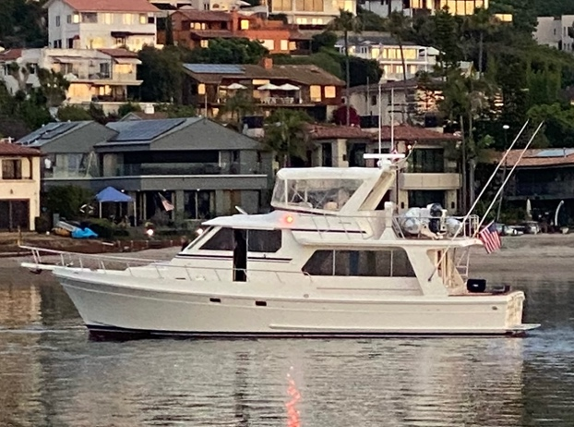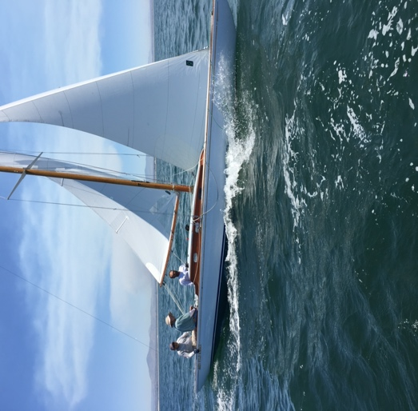

Call me direct at 619-804-1190 or email me at mike@sdsa.com
Tell me about your case or maritime situation.
Be sure to send a picture of your boat if you have one.

